**23BD1A050Y**

**GAYATHRI**

**WEEK – 4**

**SIMPLE STORAGE SERVICE – ( S3 )**

Step -1 : In aws console search for S3

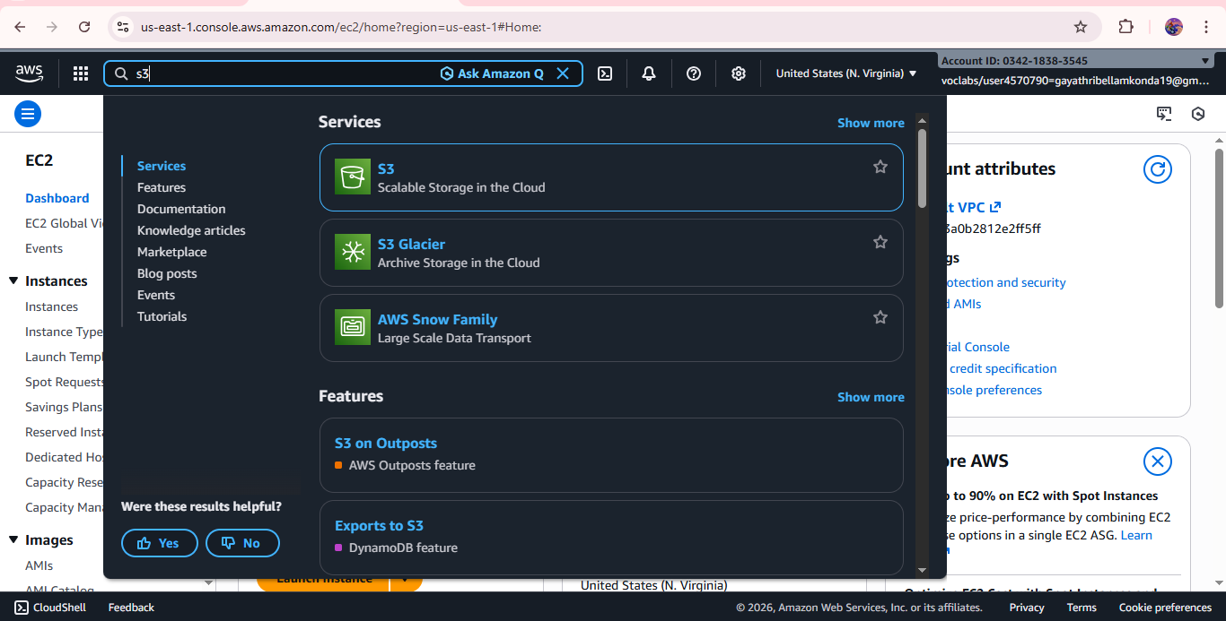

Step -2 : Click on create bucket

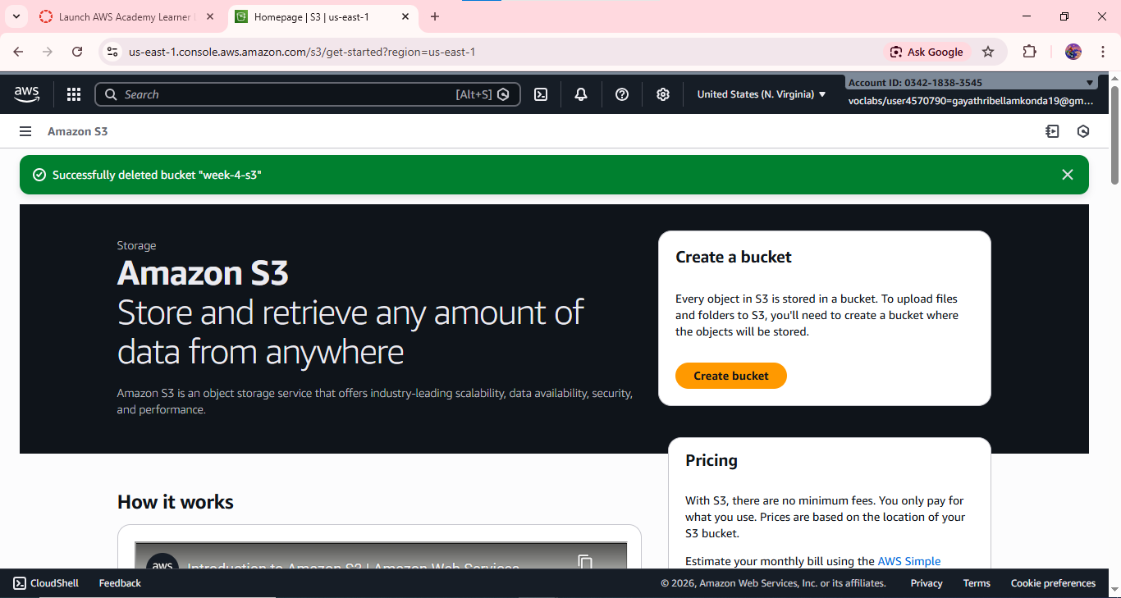

Step -3 : Provide the bucket name , keep the bucket type as default.

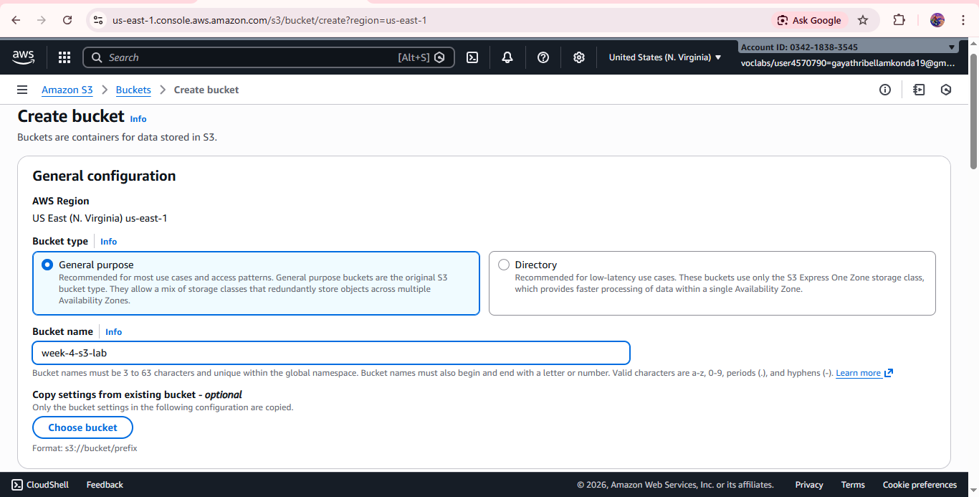

Step -4 : Leave the Object ownership – ACLs as disabled

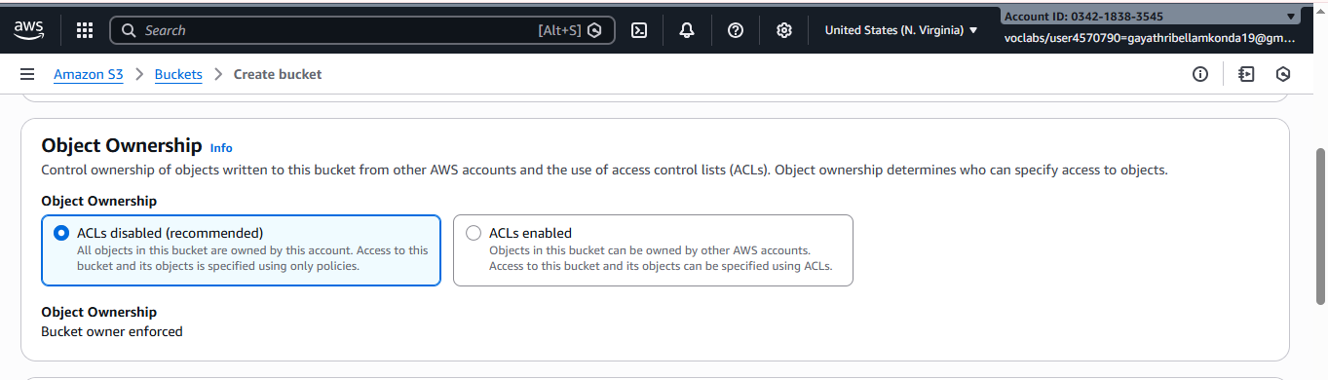

Step -5 : To give public access to the data remain the block all public access as unchecked

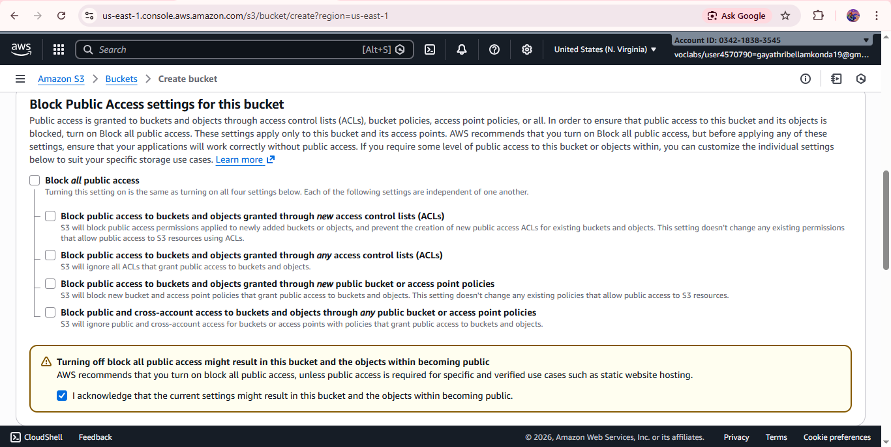

Step -6 : Leave every thing as default and click on create bucket.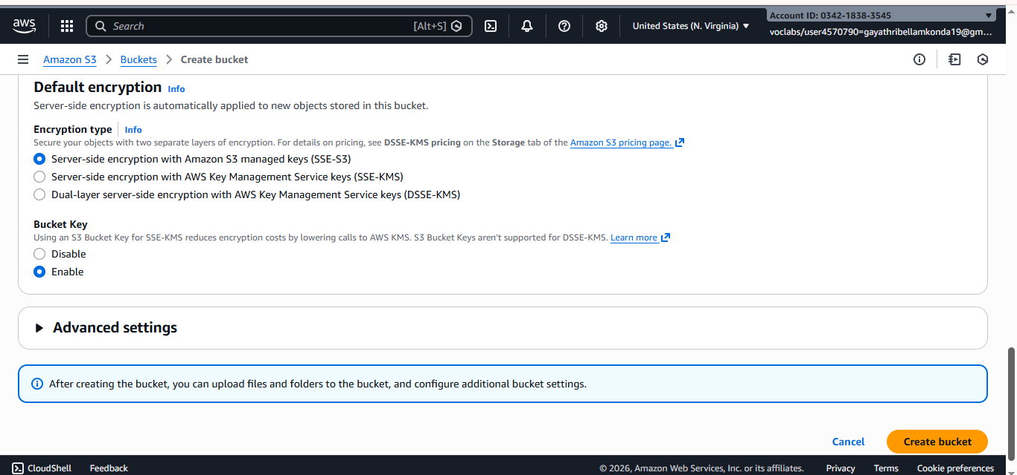

Step -7 : click on the bucket name

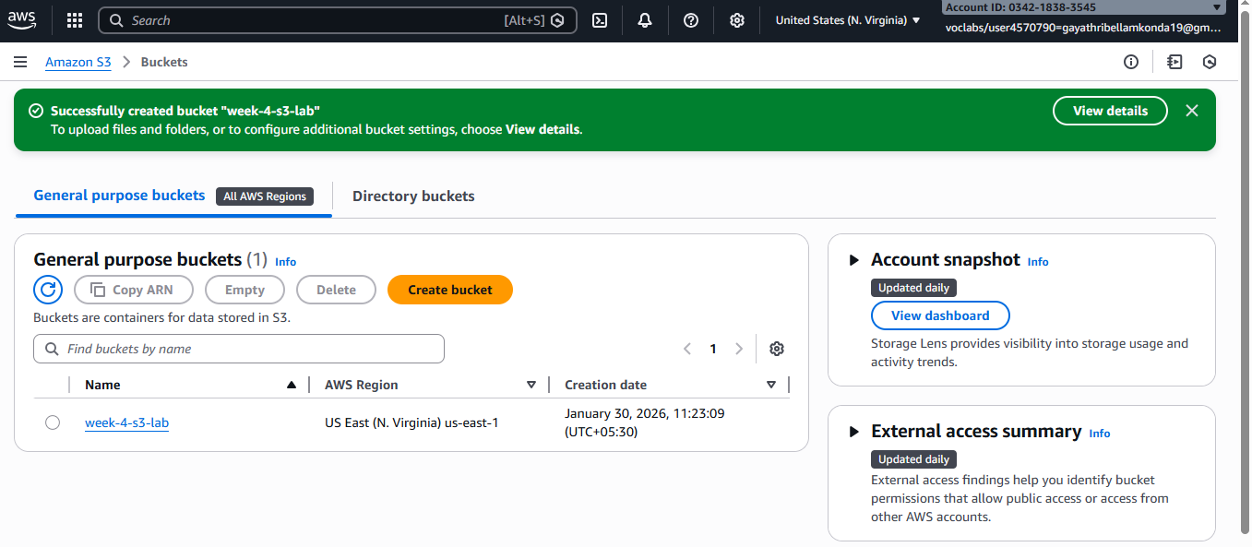

Step -8 : To add the data click on upload button.

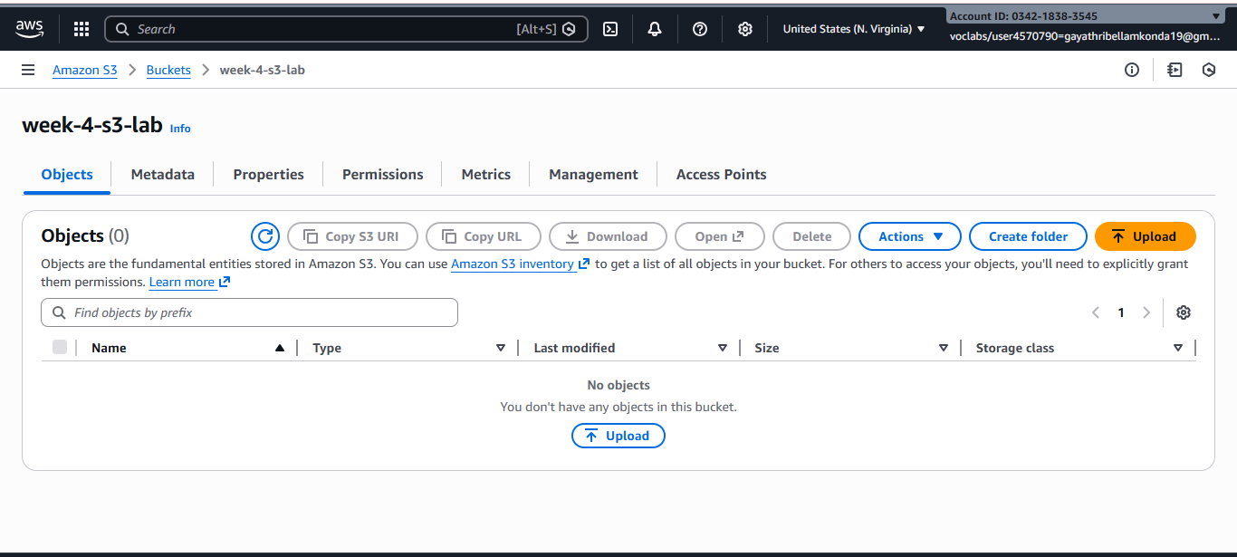

Step -9 : Click on add files

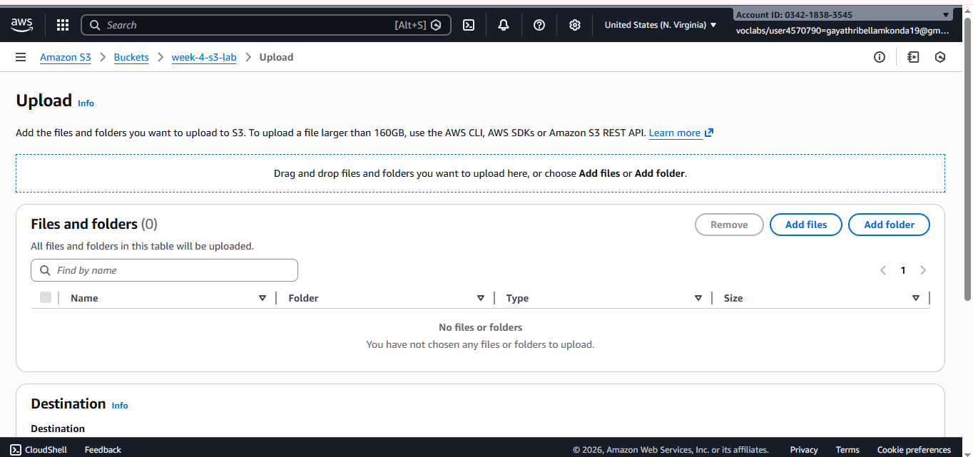

Step -10 : Select any data from the pc and click on upload

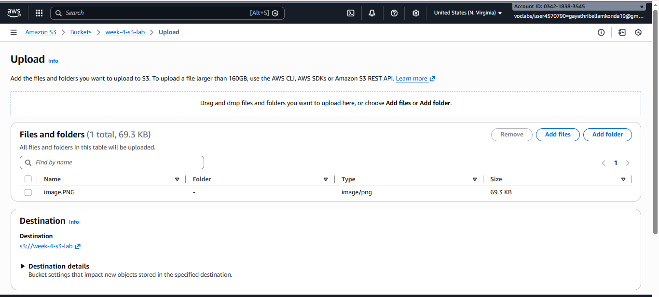

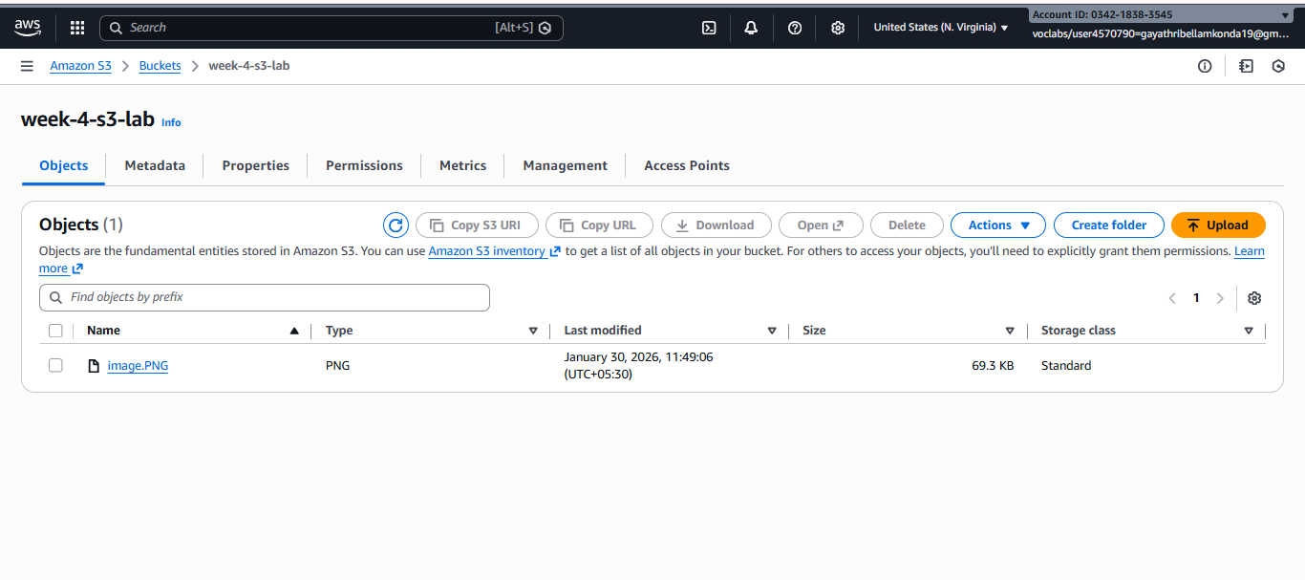

Step -11 : Click on image object -> copy the object url.

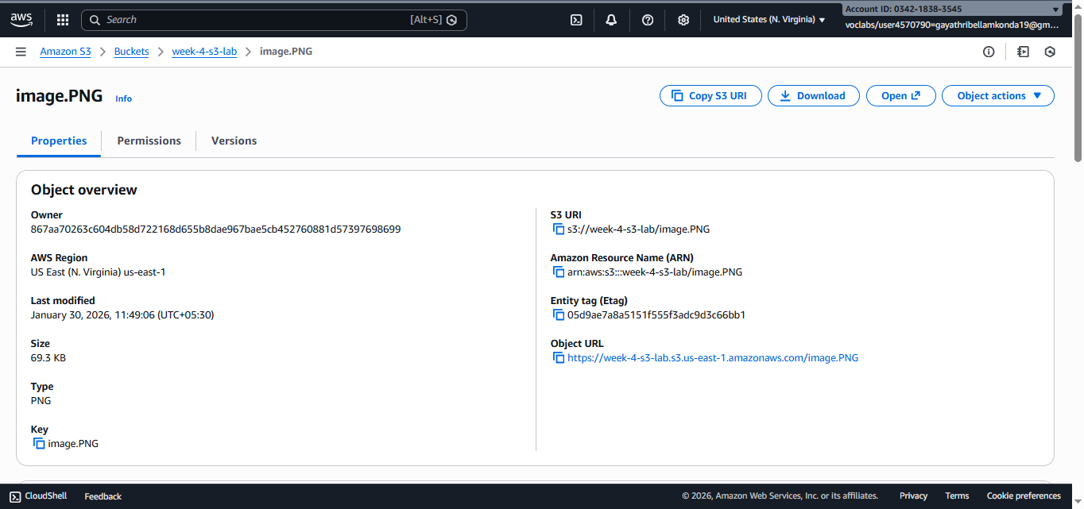

Step -12 : Open browser paste the url - > The image will not be displayed (There is public access for image)

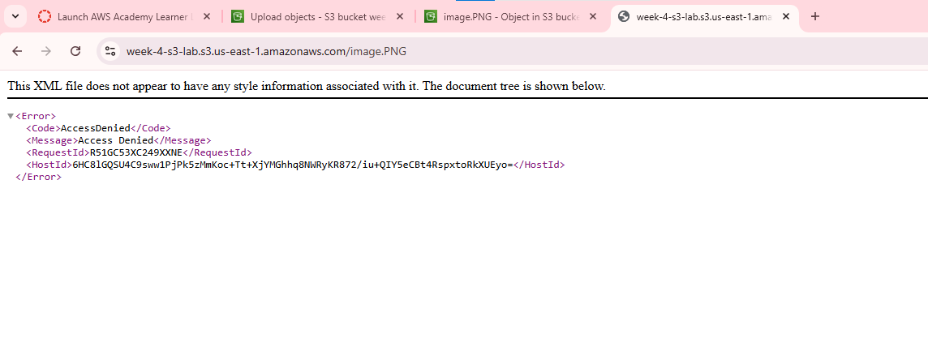

Step -13 : click on bucket name -> go to permissions

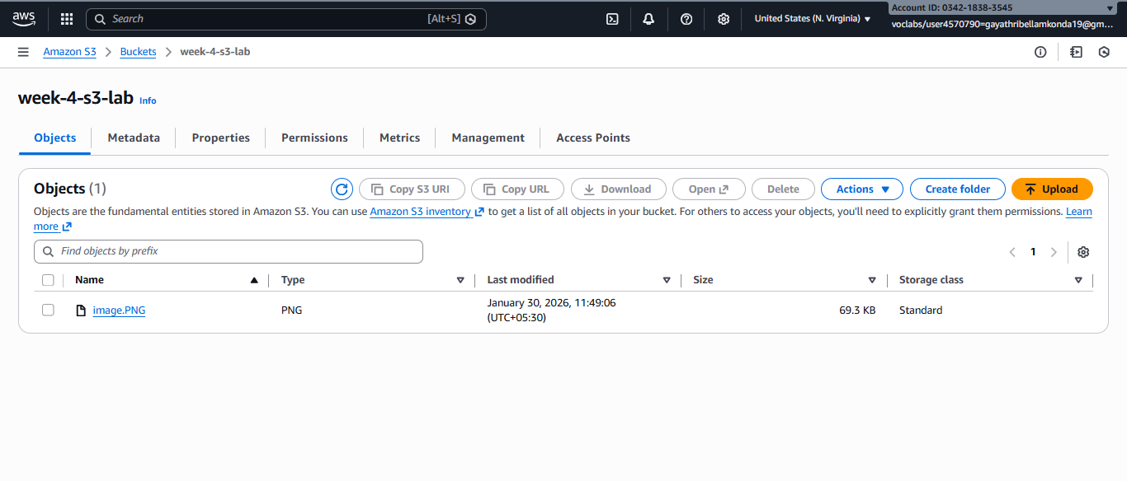

Step -14 : click on edit of block public access

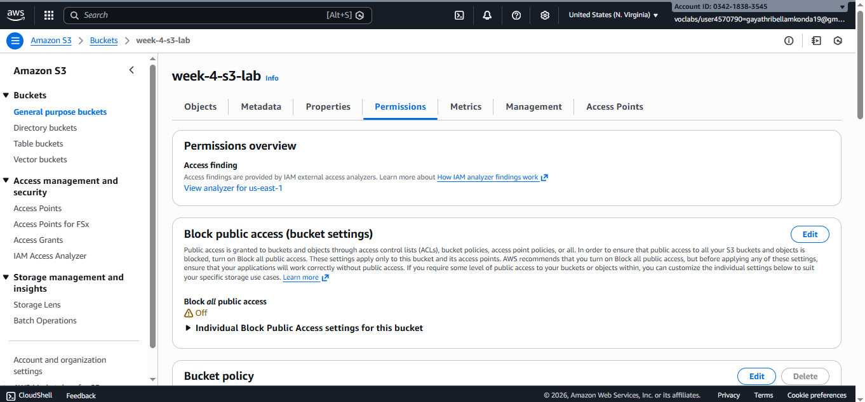

Step -15 : Uncheck the block public access -> click on save changes

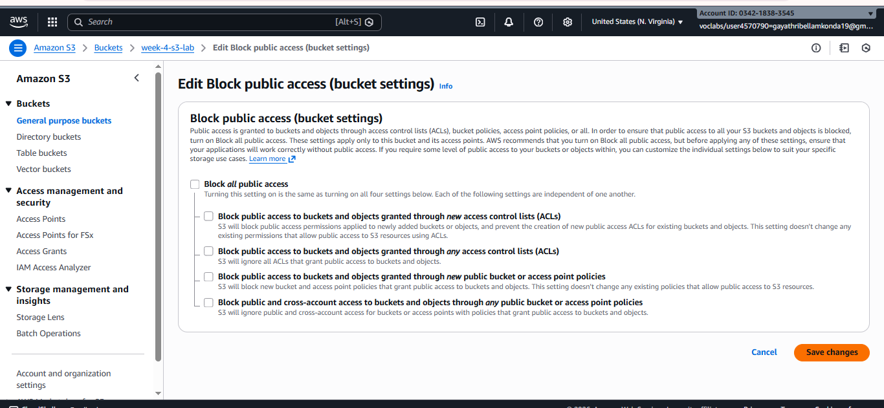

Step -16 : Go to object ownership -> click on edit

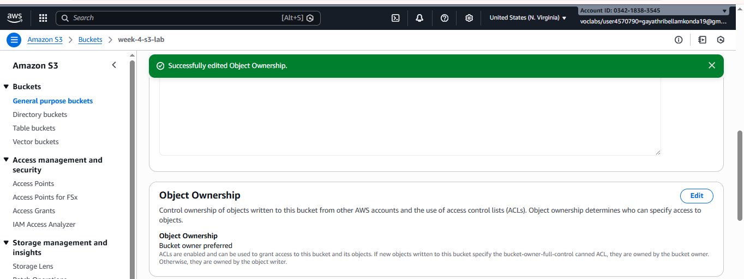

Step -17 : select ACLs enabled -> click on save changes

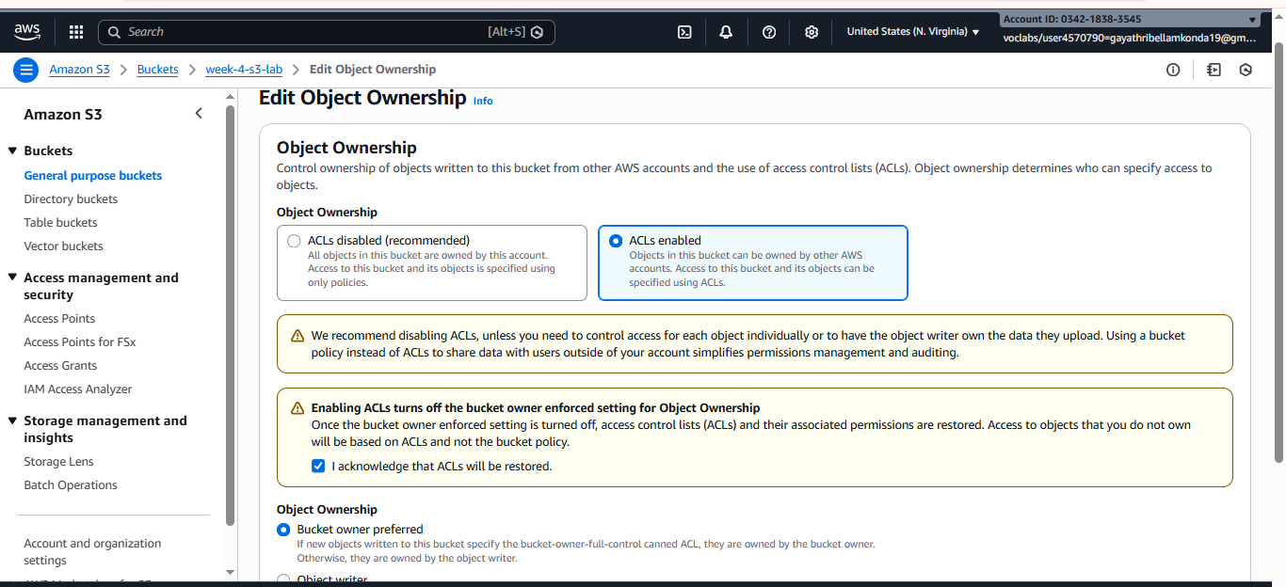

Step -18 : click edit button of Access control list

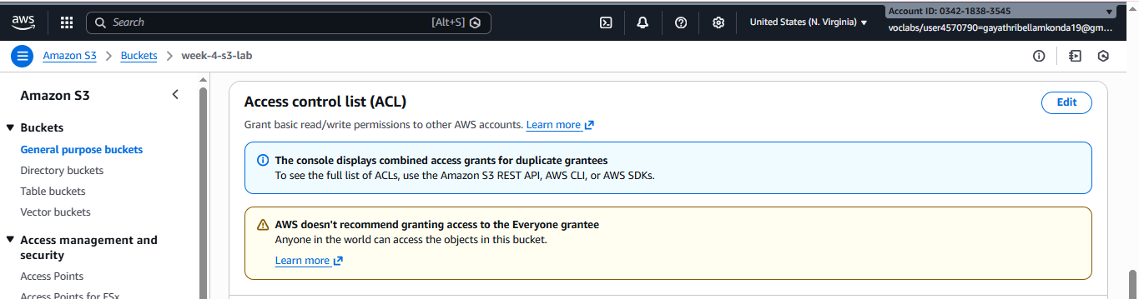

Step -19 : select object list and bucket read of public access

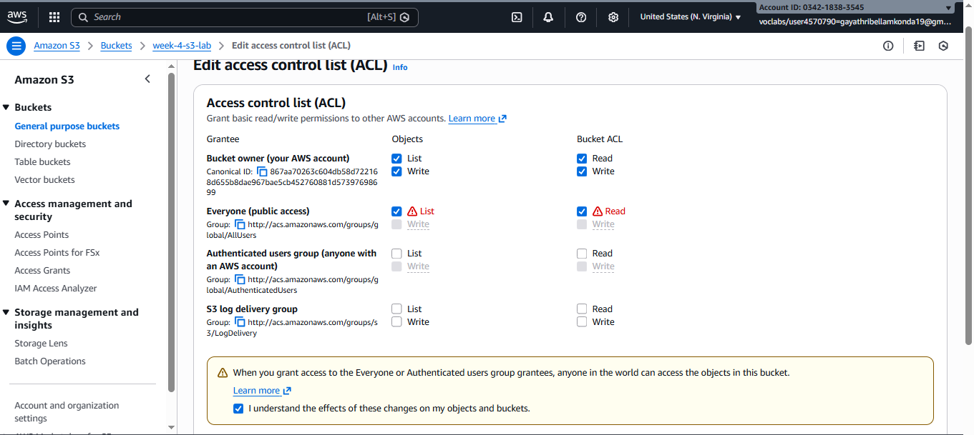

Step -20 : click on image -> go to object level permissions



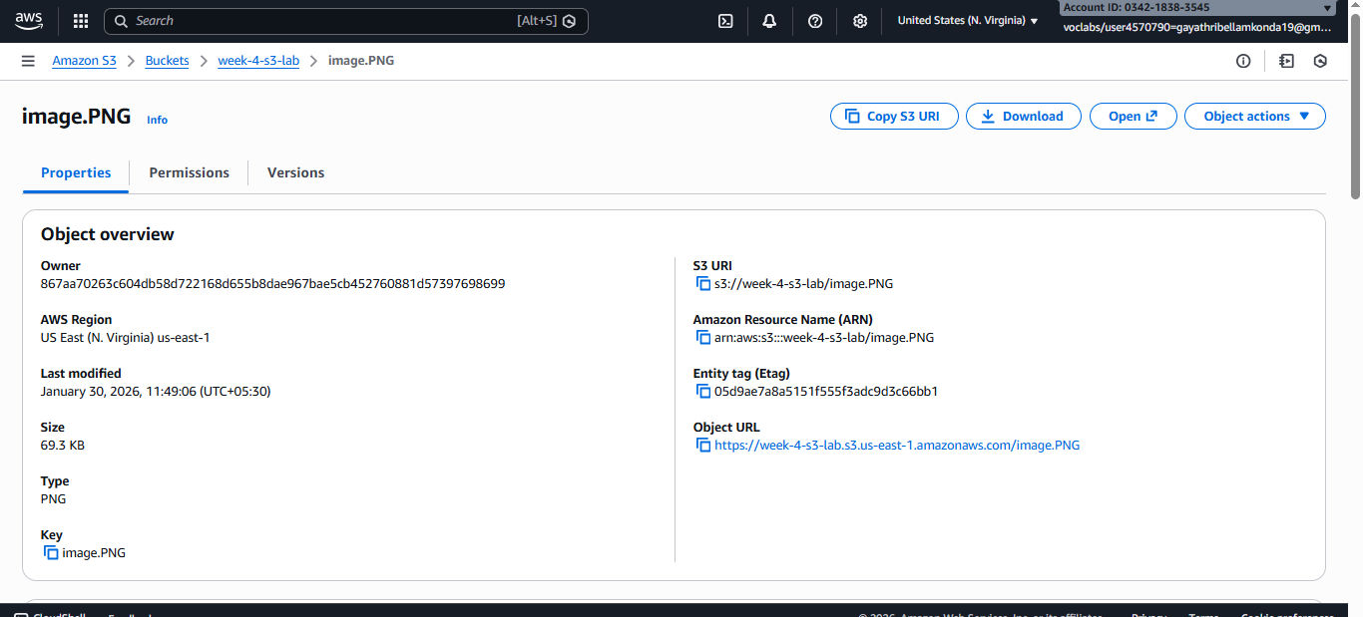

Step -21 : click on edit button of access control list

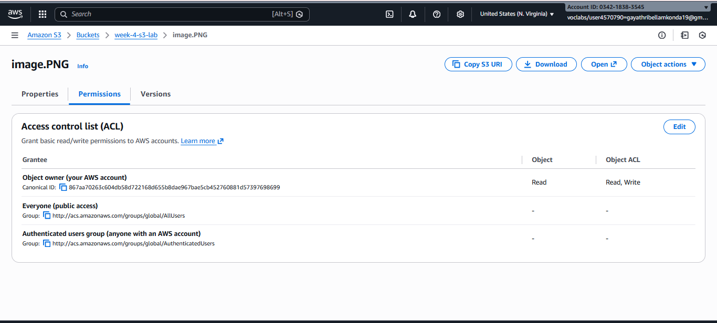

Step -22 : select read and list of public access

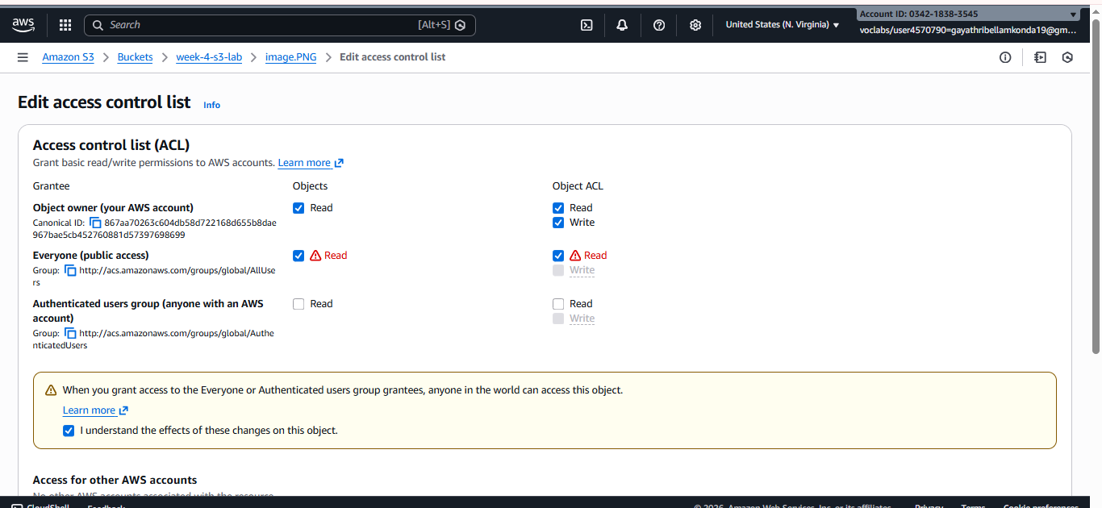

Step -23 : Now copy the object url

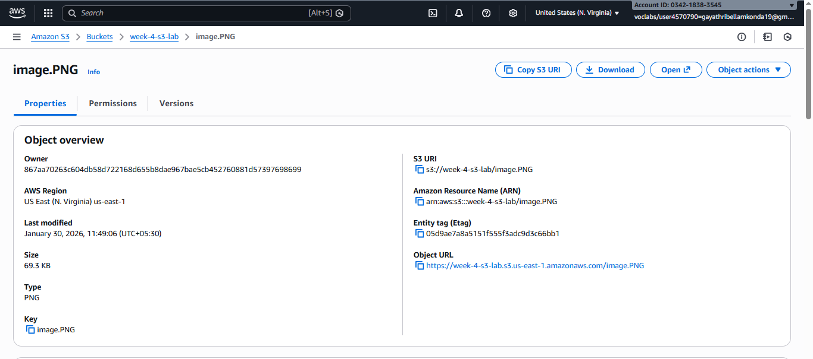

Step -24 : paste it on browser the image will be displayed

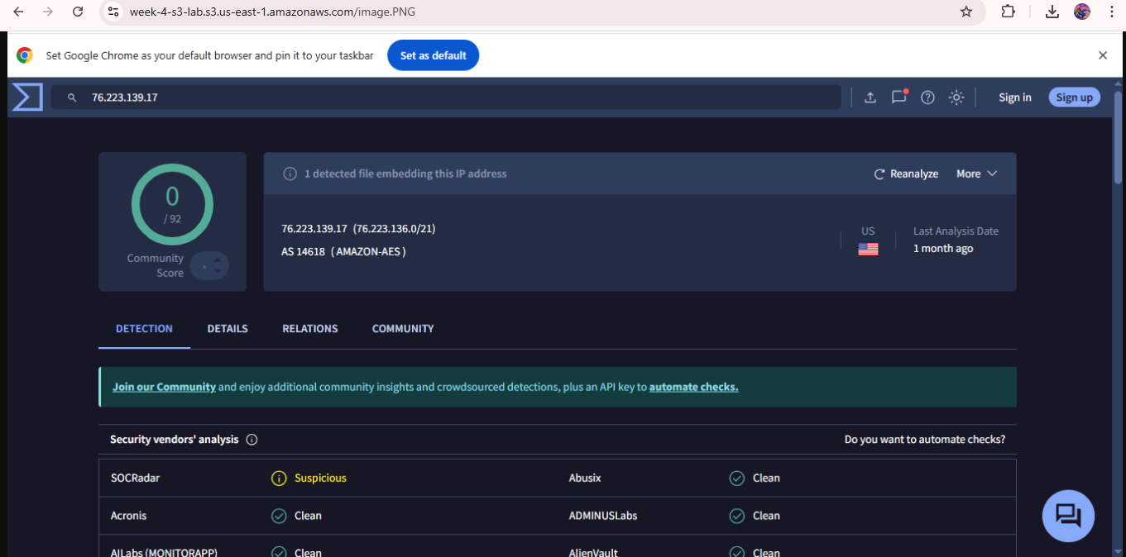

**Image Versioning**

Step -1 : Go to image -> click on upload

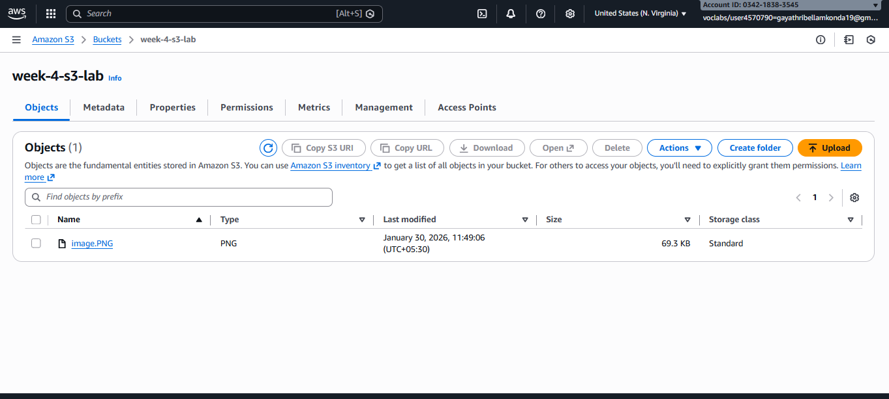

Step -2 : Add the same file which is already present -> click on upload

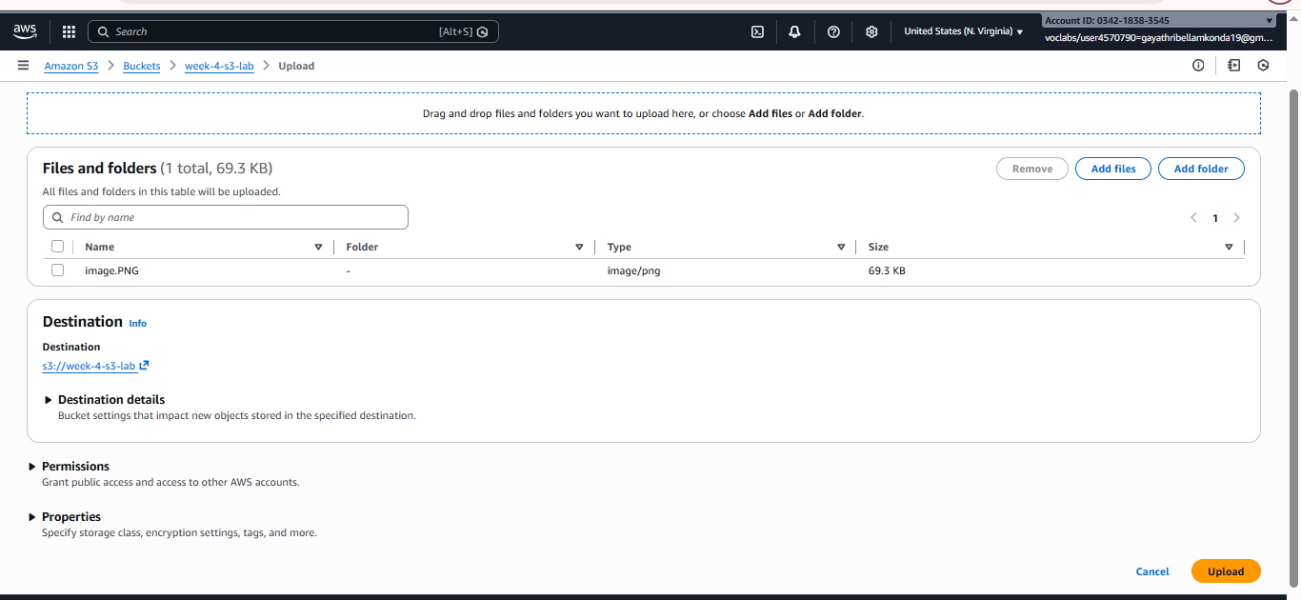

Step -3 : Image versions is not showing

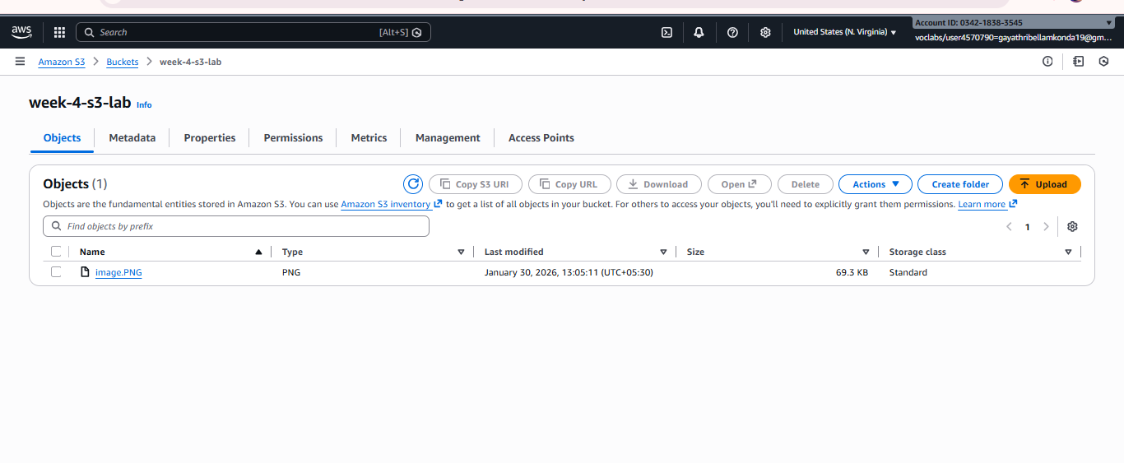

Step -4 : Go to properties -> click on edit option of bucket versioning

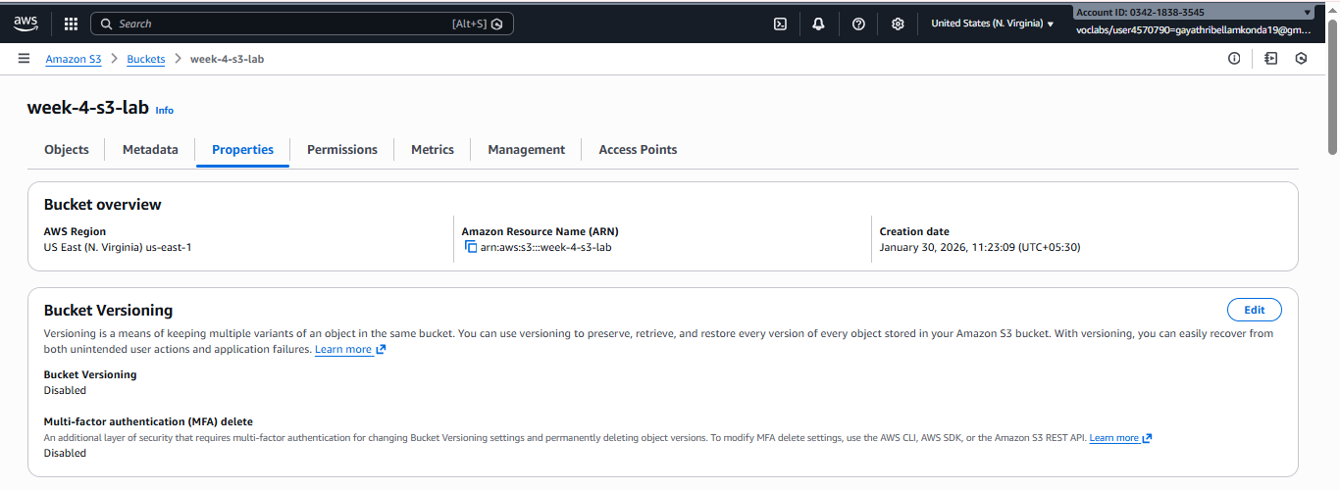

Step -5 : enable the bucket versioning -> click on save changes

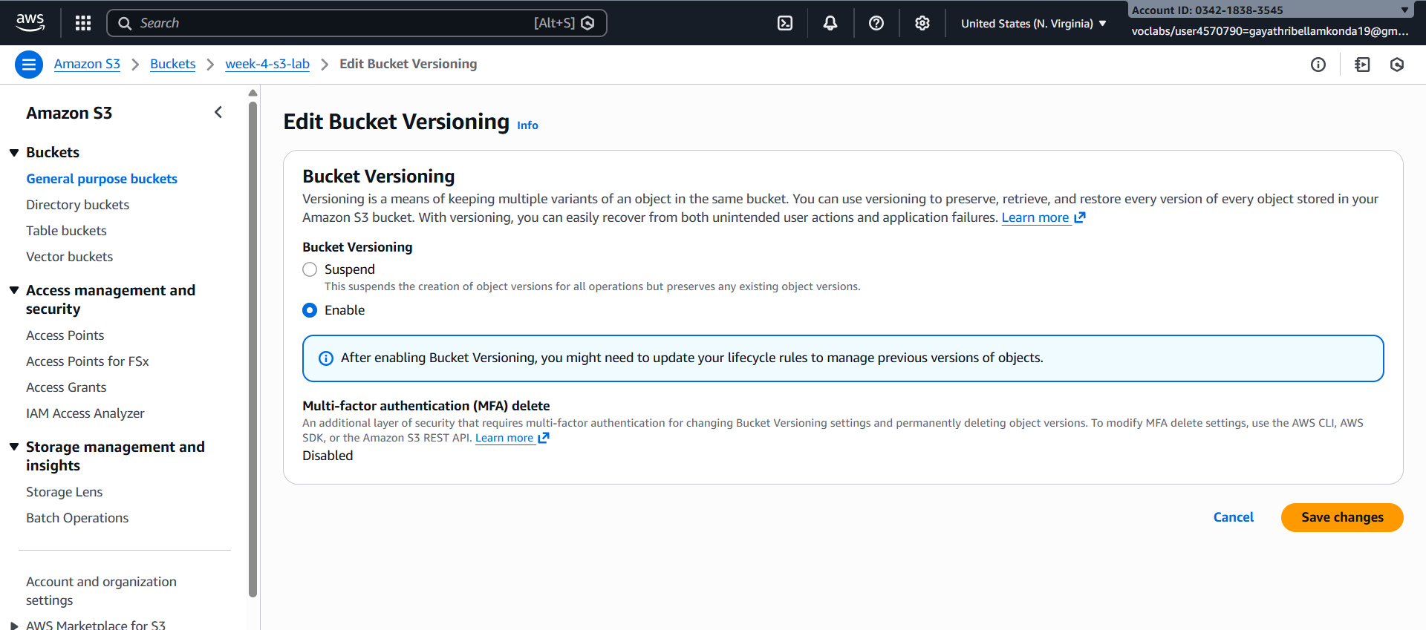

Step -6 : toggle the show version to see the images

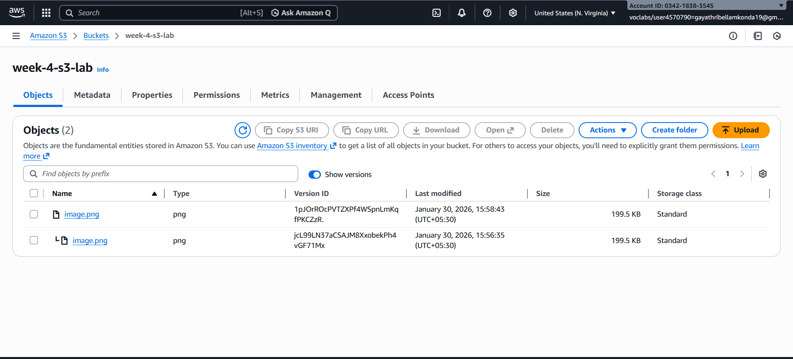

Step -7 : Select the image -> click on delete

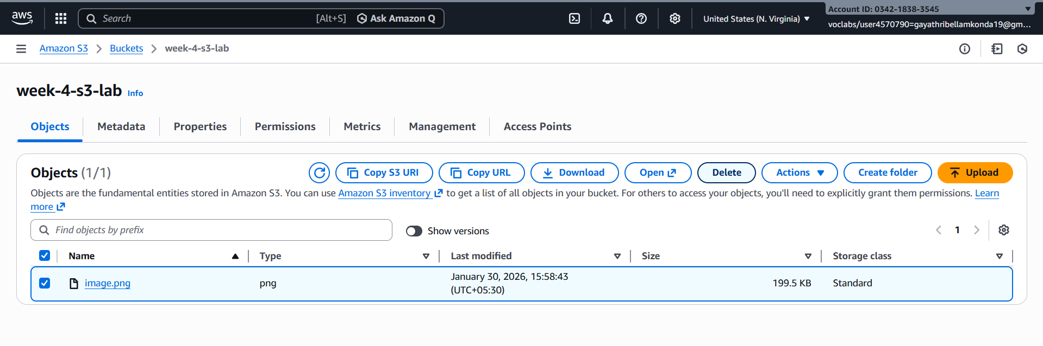

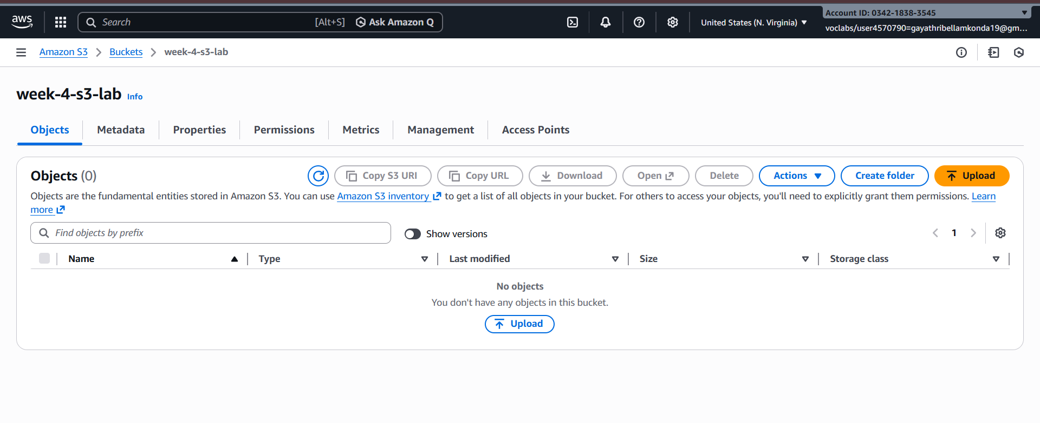

Step -8 : But still images will be present when we toggle the show versions along with the delete marker

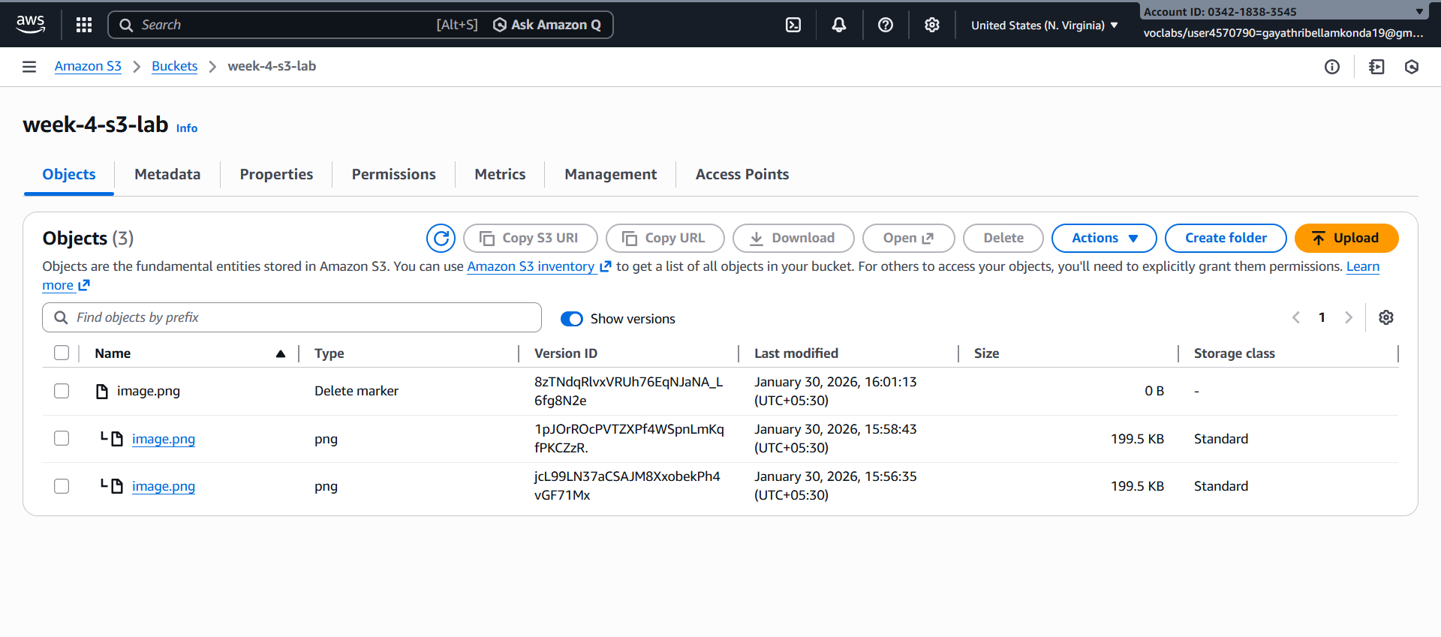

Step -9 : Select all the images and click on delete , it will permanently delete the images

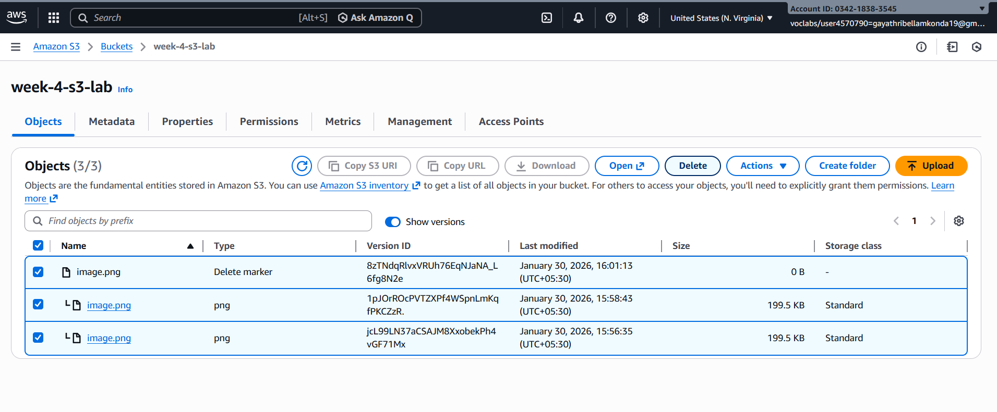

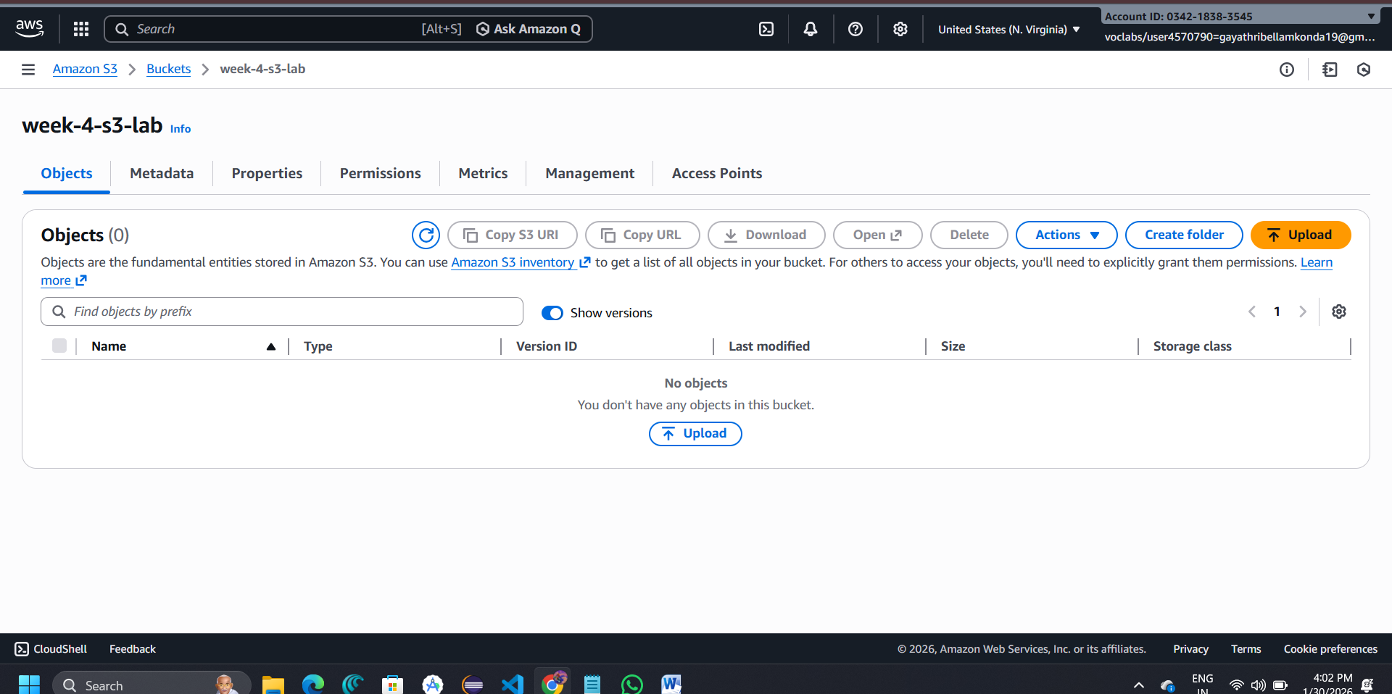

**OBJECT REPLICATION**

Step -1 :create a bucket in N.Virginia

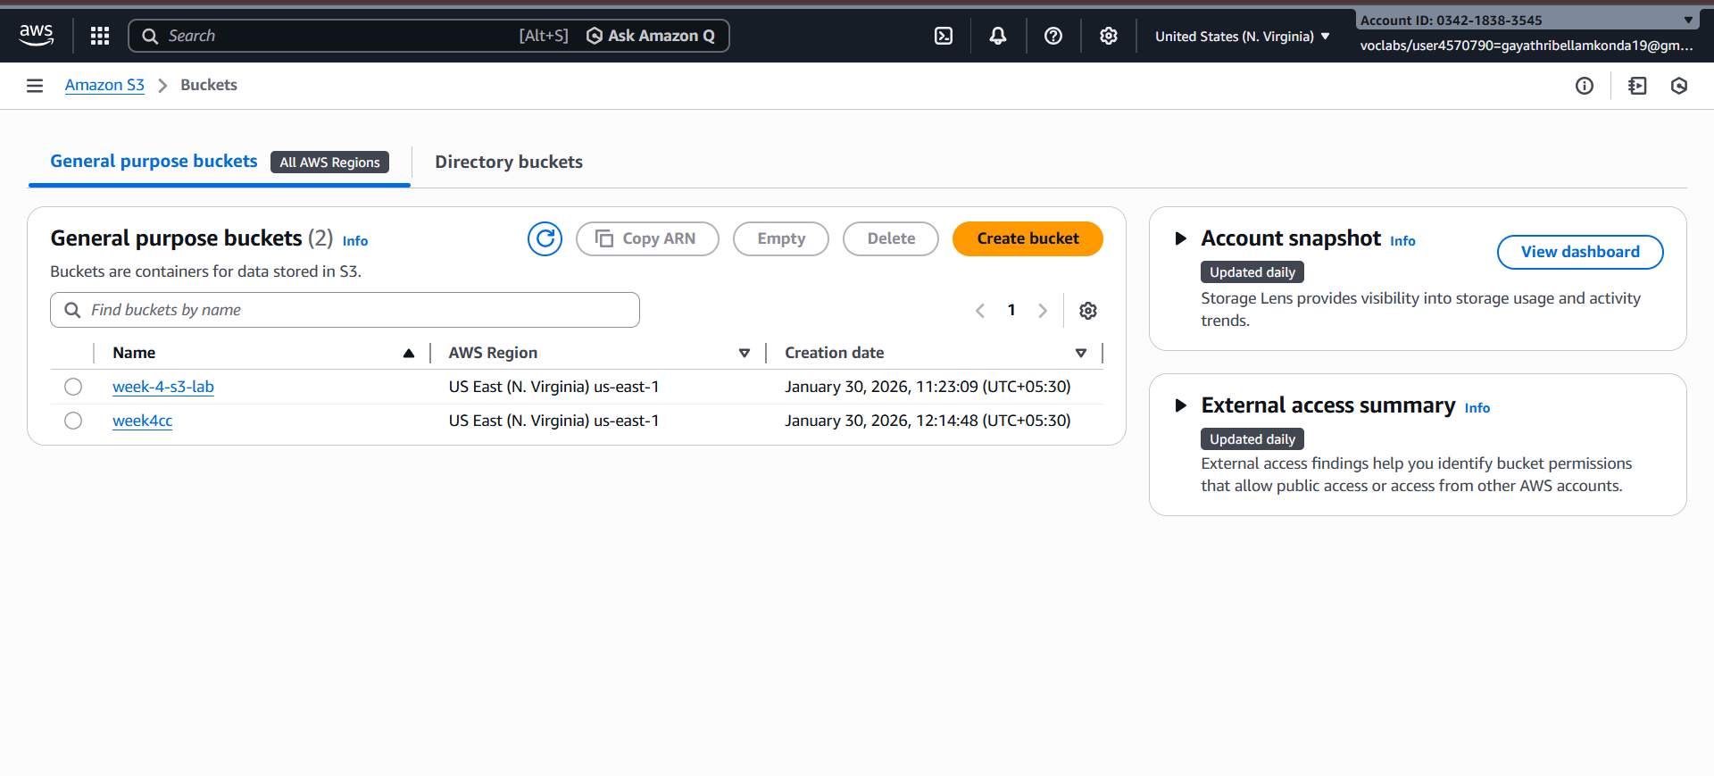

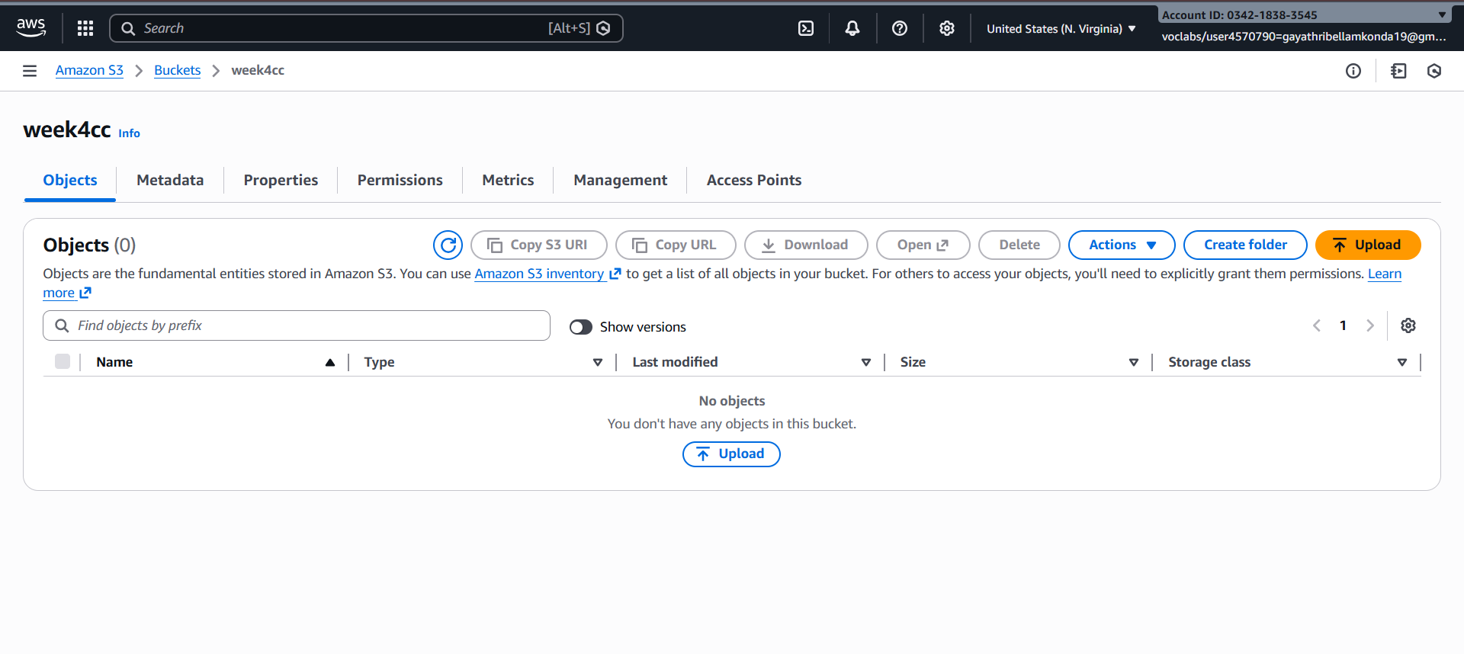

Step -2 : Create another bucket in Oregon-> enable the ACLs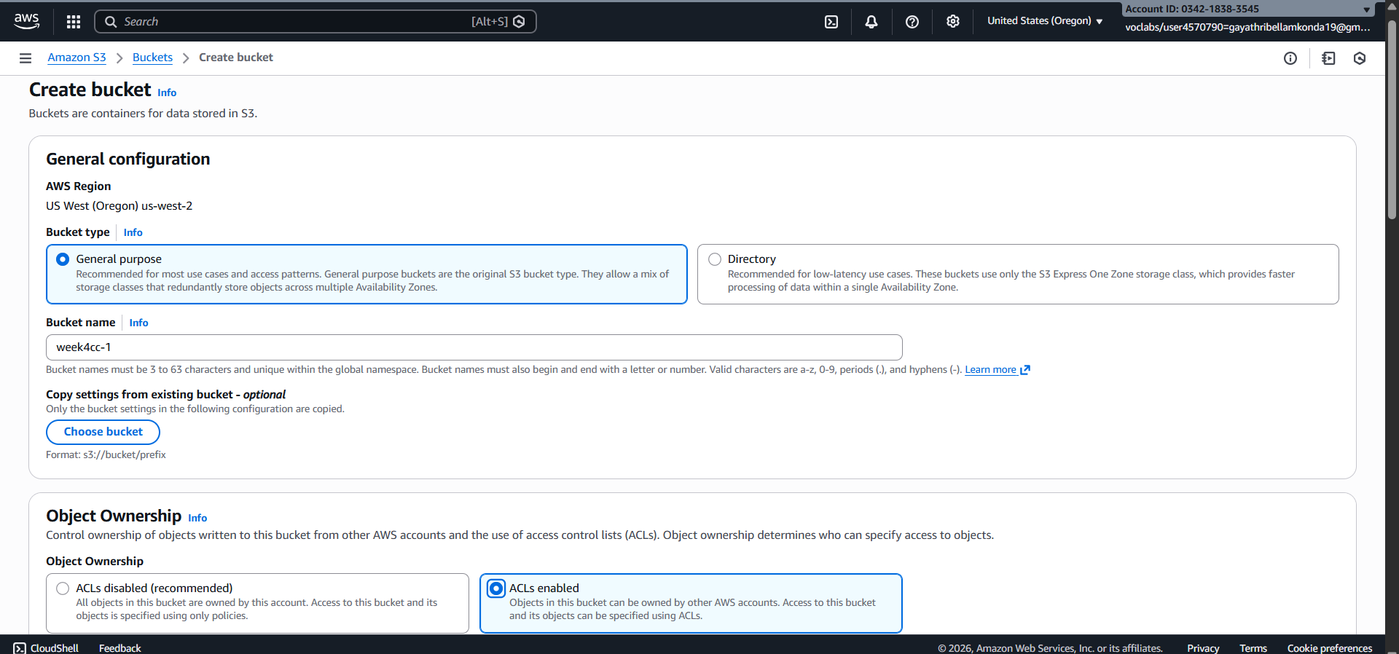

Step -3 : Uncheck the bucket public access -> create the buket

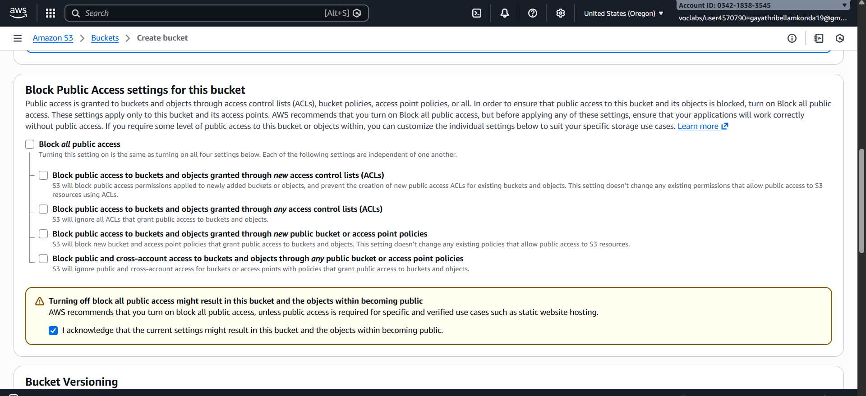

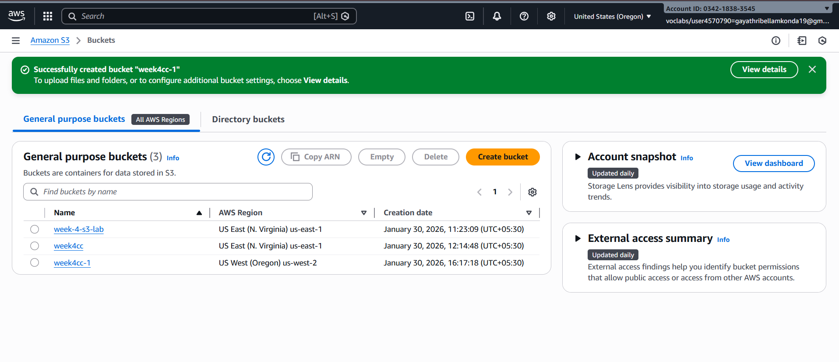

Step -4 : Click on bucket In Oregon region -> Go to management

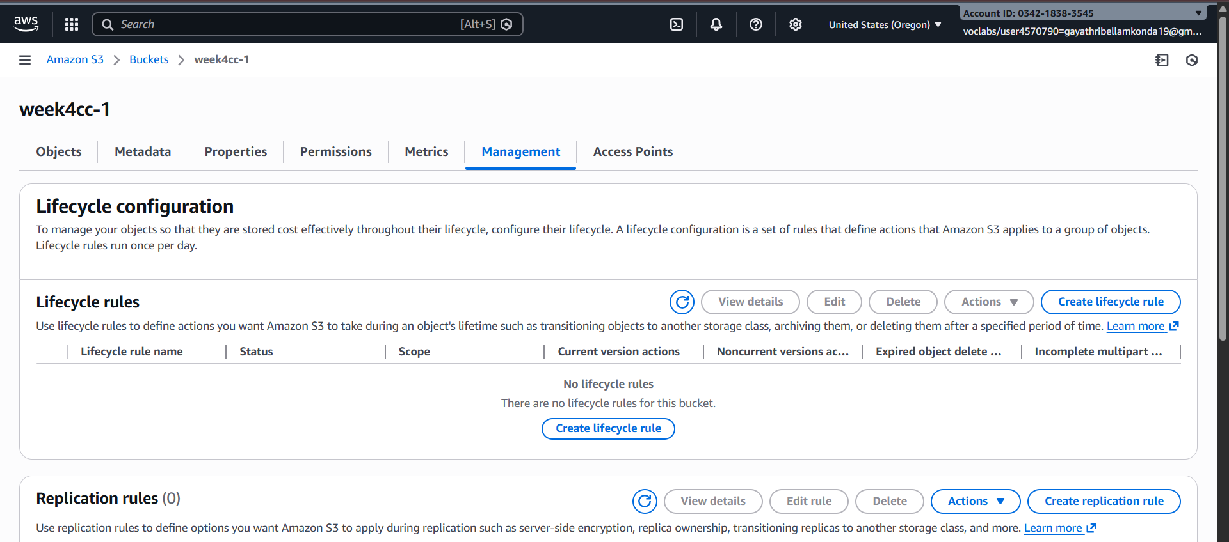

Step -5 : Click on create replication rules

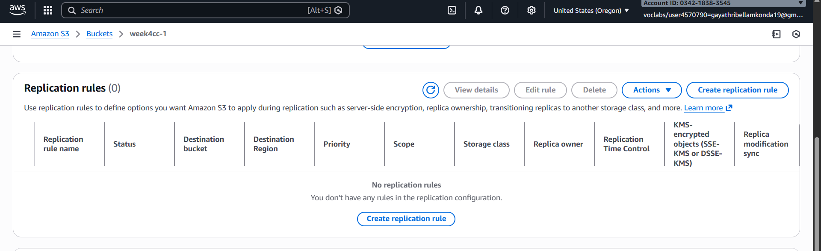

Step -6 : Provide the name to the rule

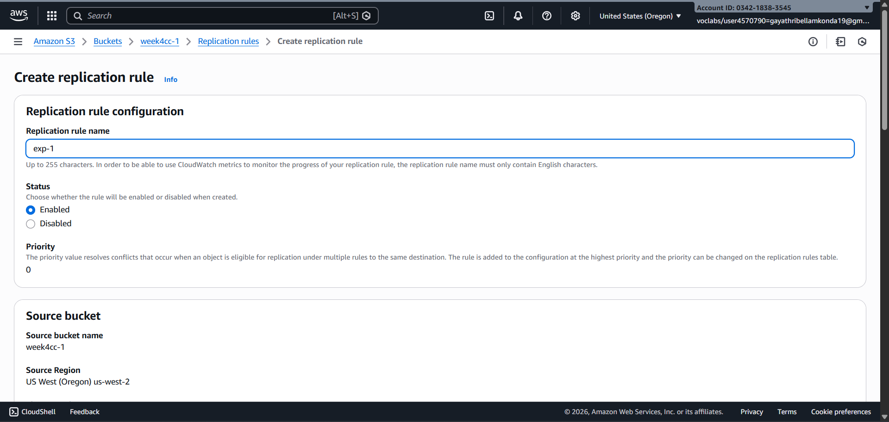

Step -7 : select Apply to all objects in the bucket

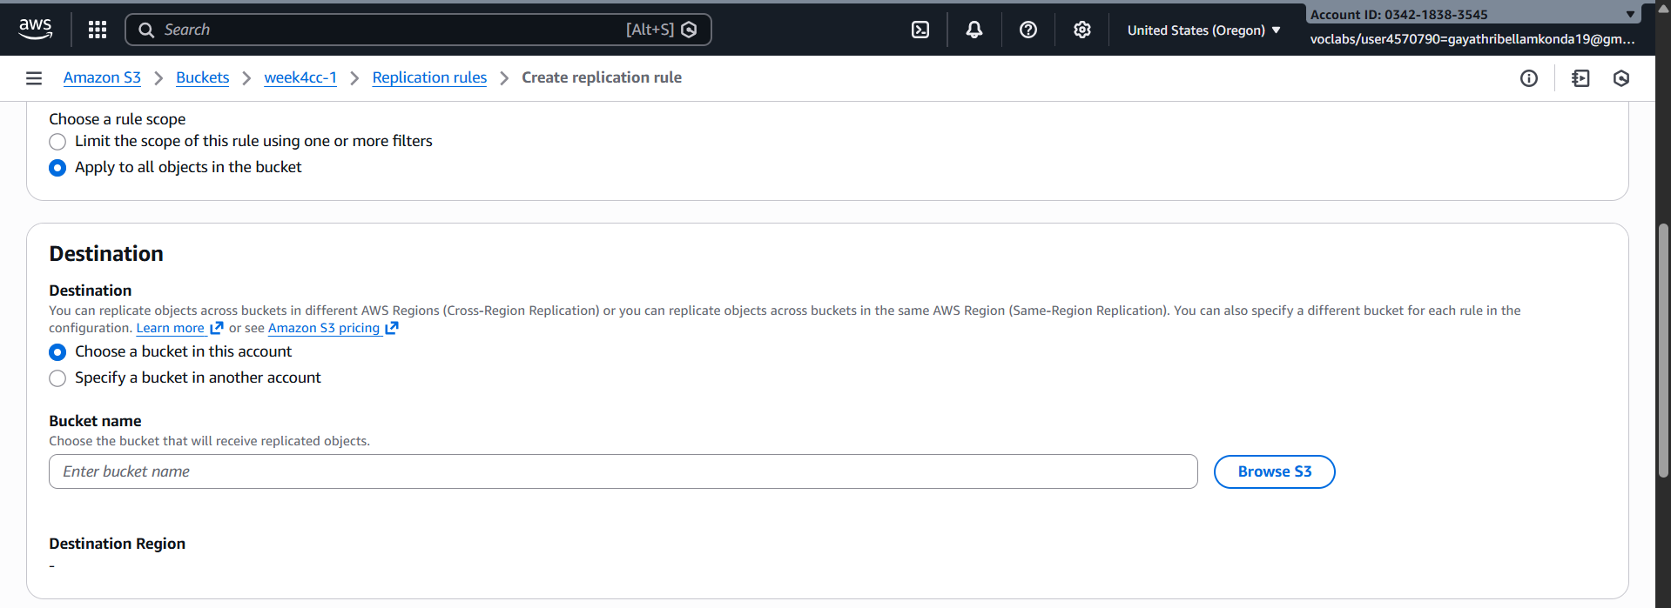

Step -8 : select choose a bucket in this account -> select the destination bucket in another region

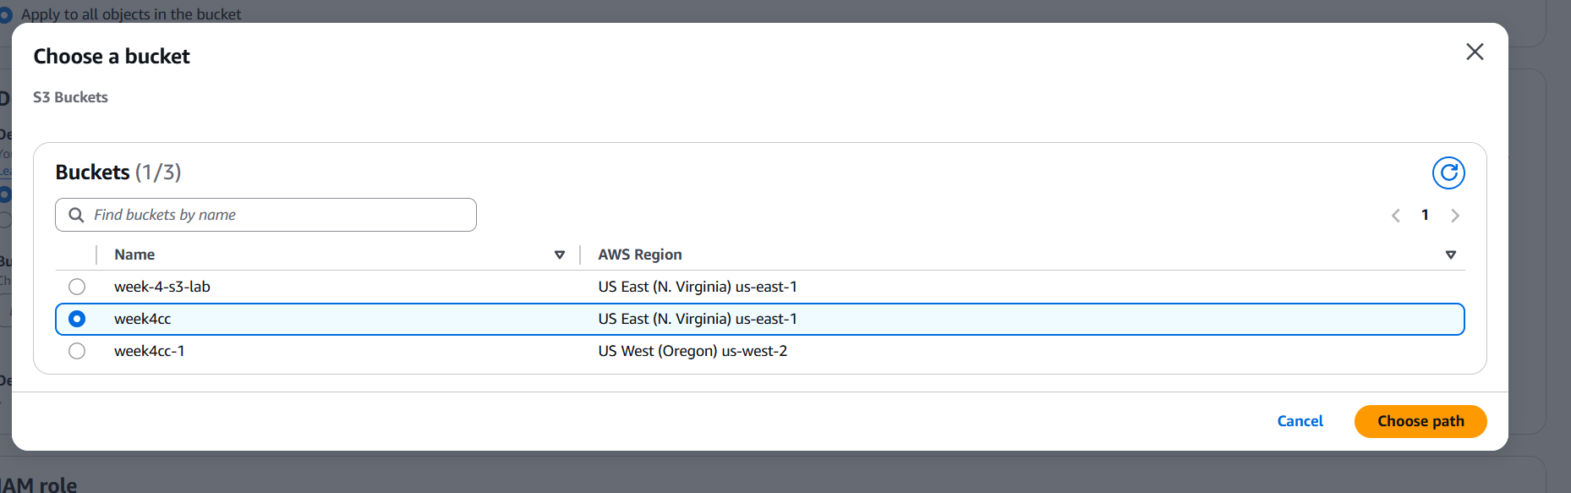

Step -9 : Choose the IAM role as LabRole

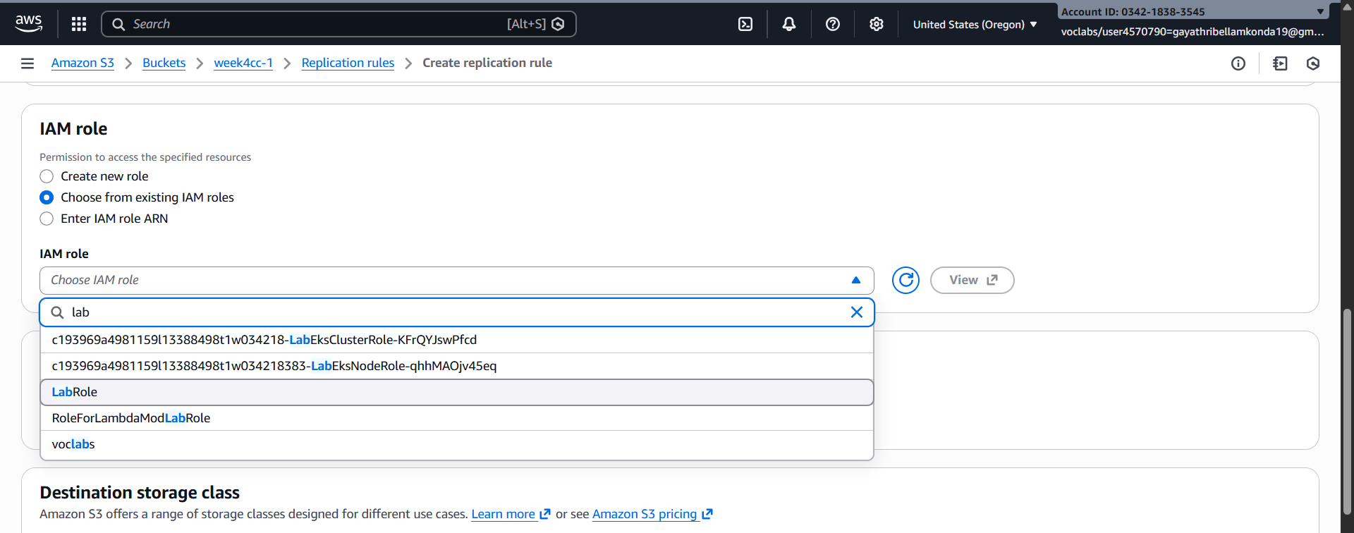

Step -10 : Everything go by default -> click on save.

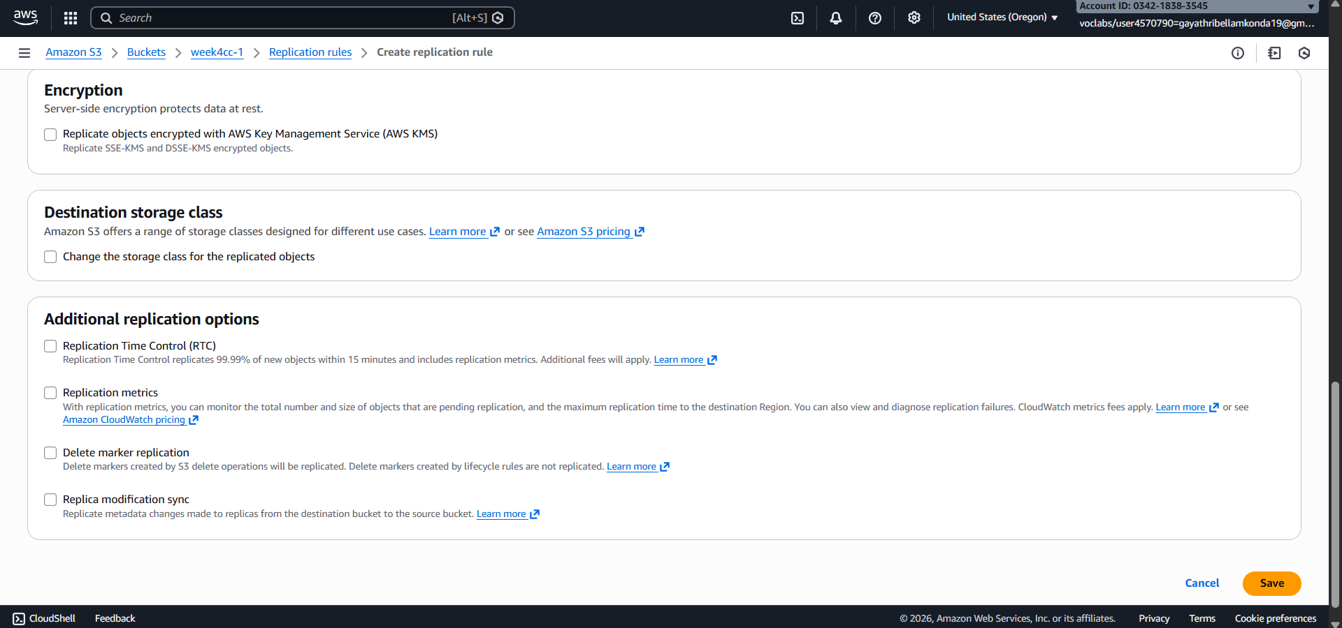

Step -11 : Upload any document in Oregon bucket

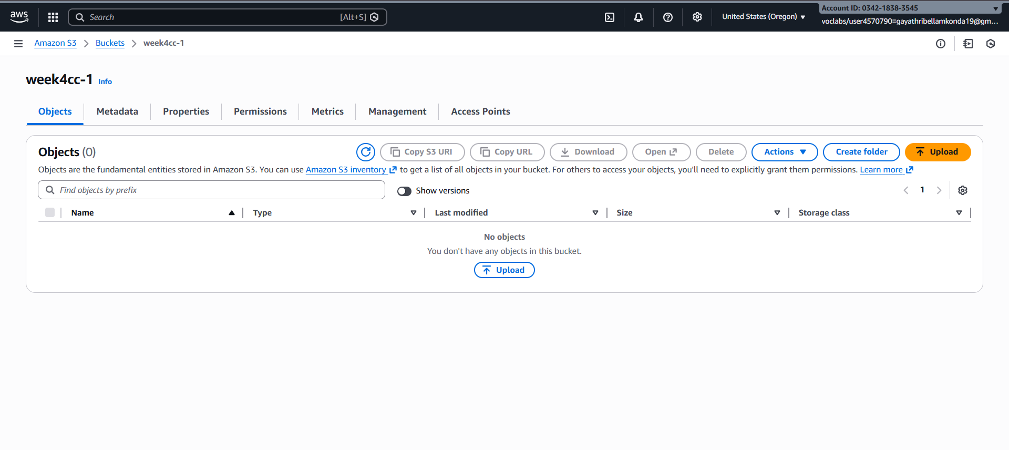

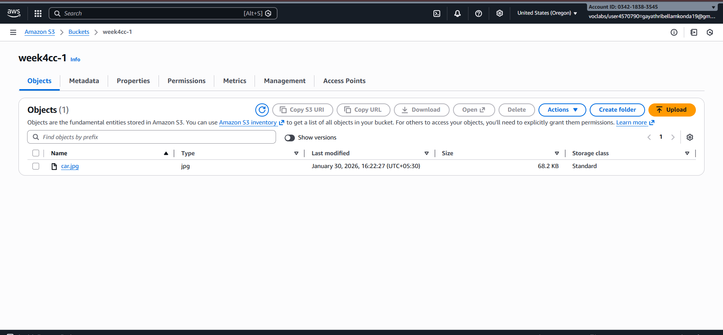

Step -12 : Same document will be automatically comes in destination bucket

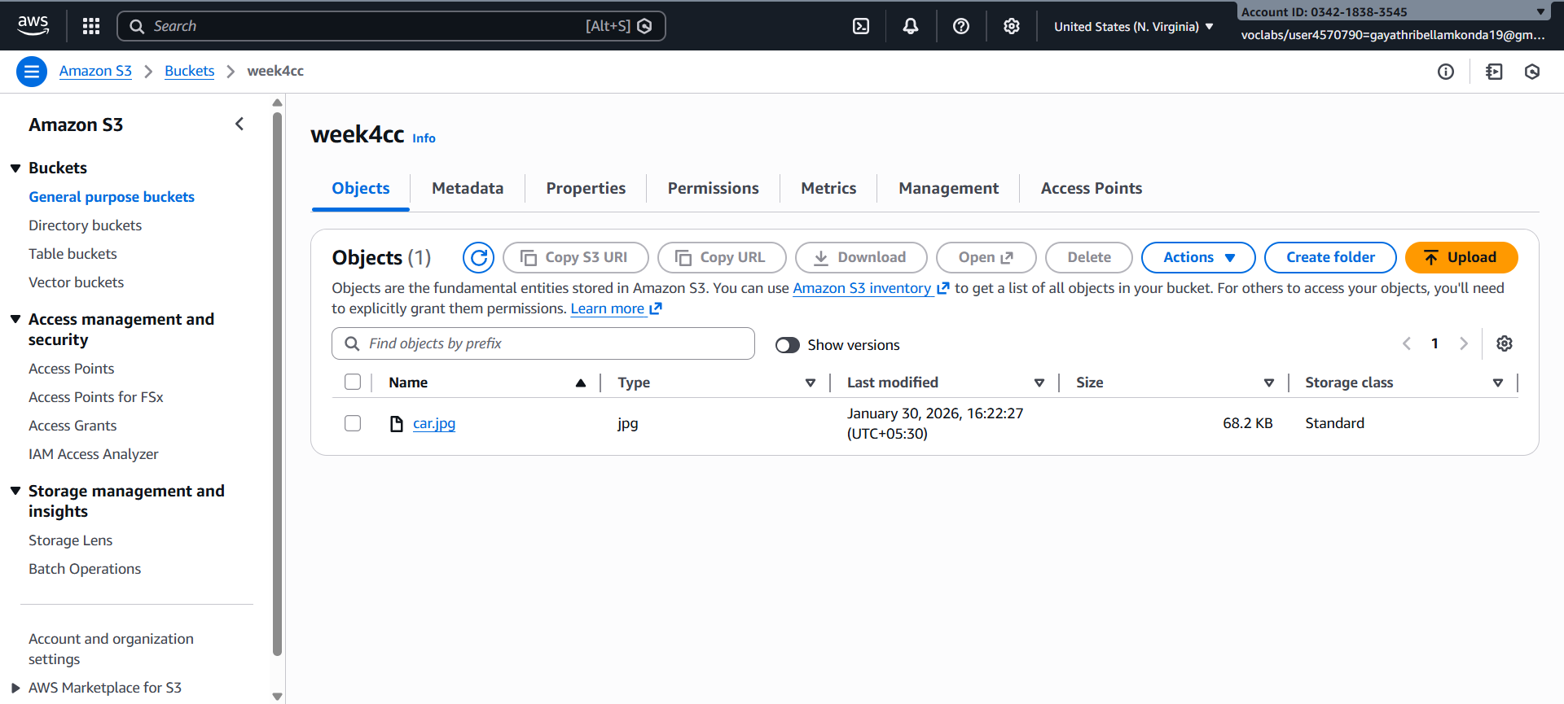

**STATIC WEB HOSTING**

Create a index.html and write code

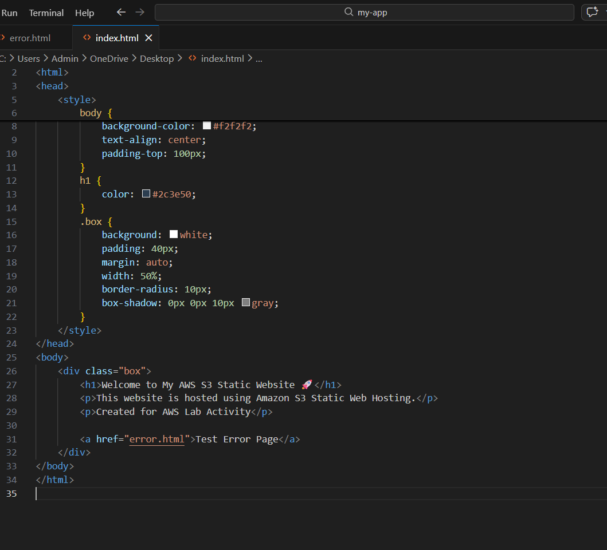

**Create another html file called error.html which has an error message**

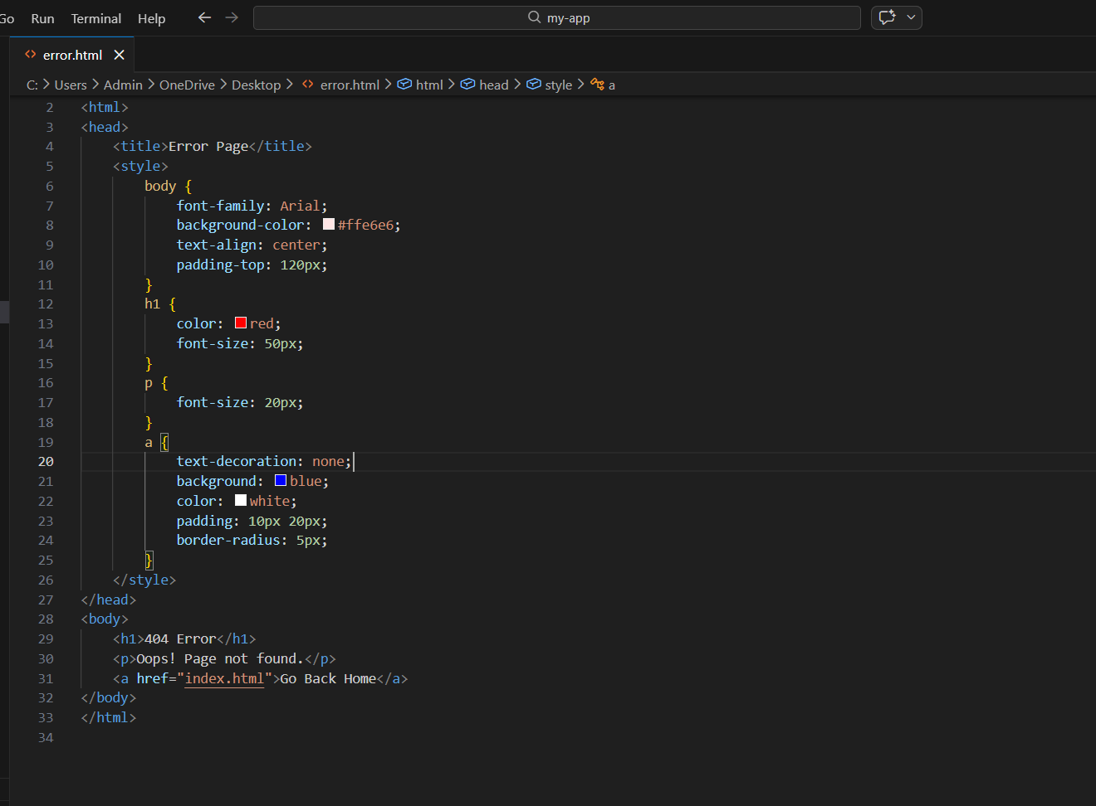

Go to aws console -> Go to Services → S3 -> click on create bucket -> Bucket name : my-static-web-hosting123

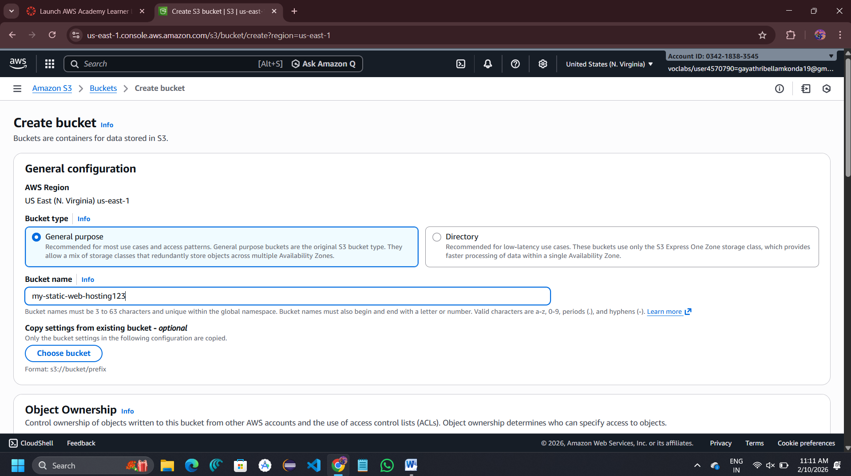

**Under Block Public Access ->** Uncheck Block all public access **->** Acknowledge the warning

Click on Create bucket

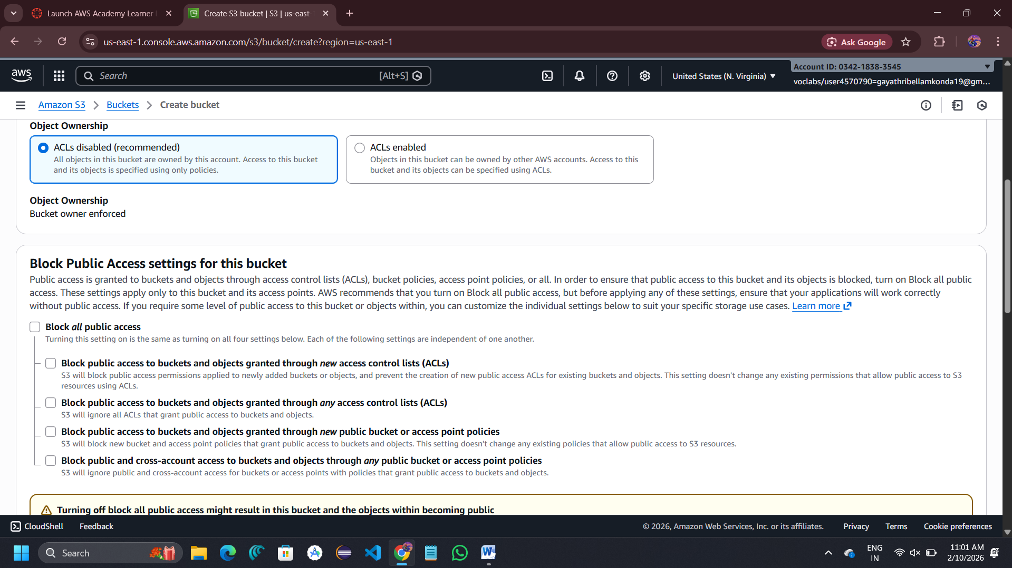

Open the bucket-> go to objects tab -> click on upload

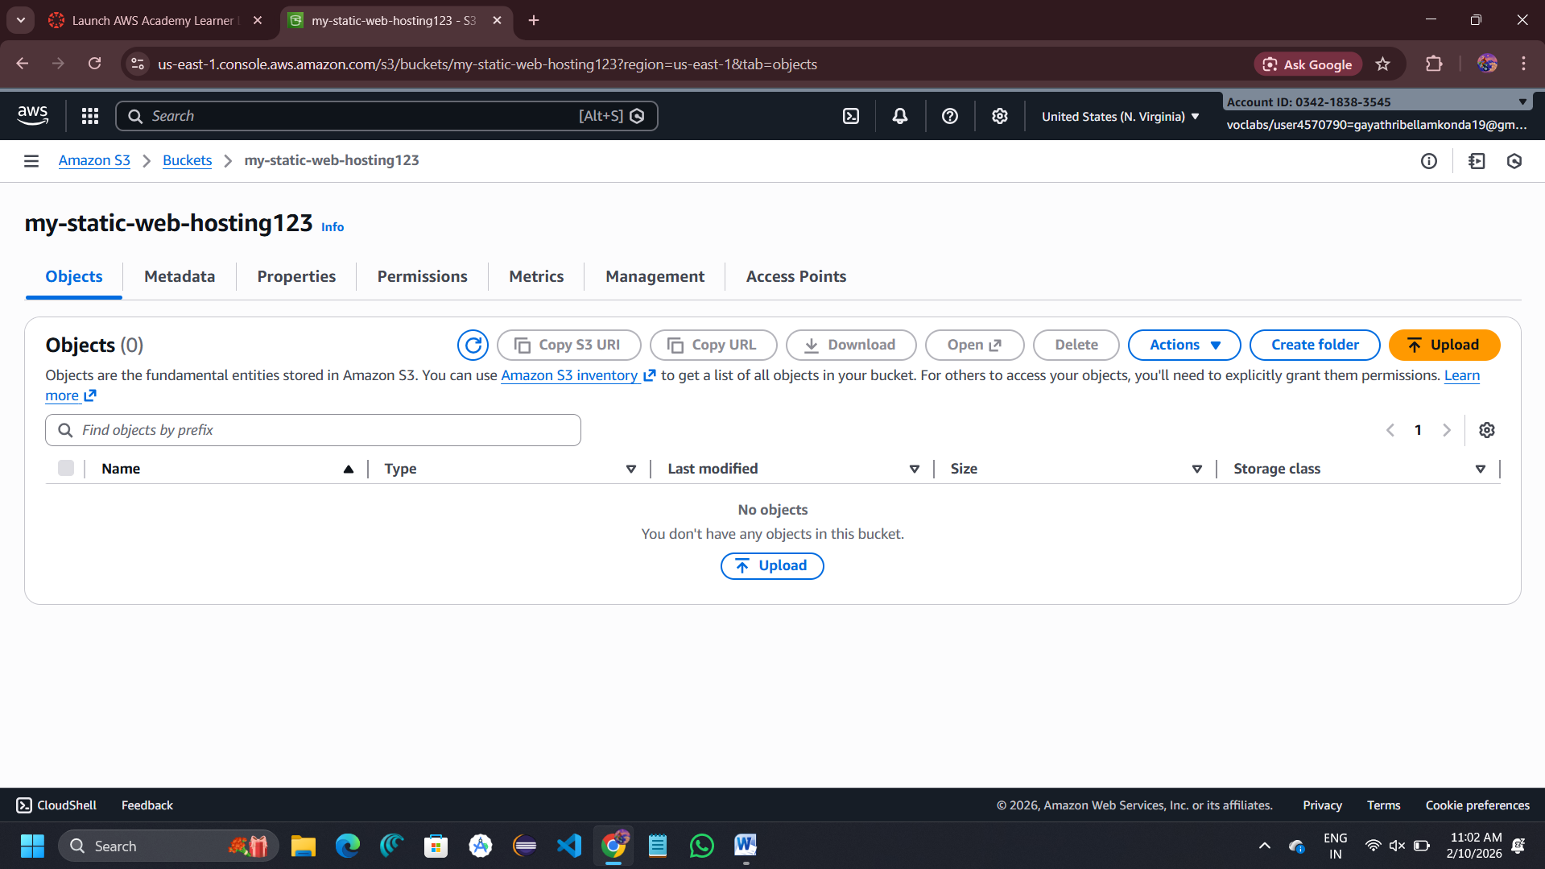

Click on add files -> select index.html and error.html files -> click on uplaod

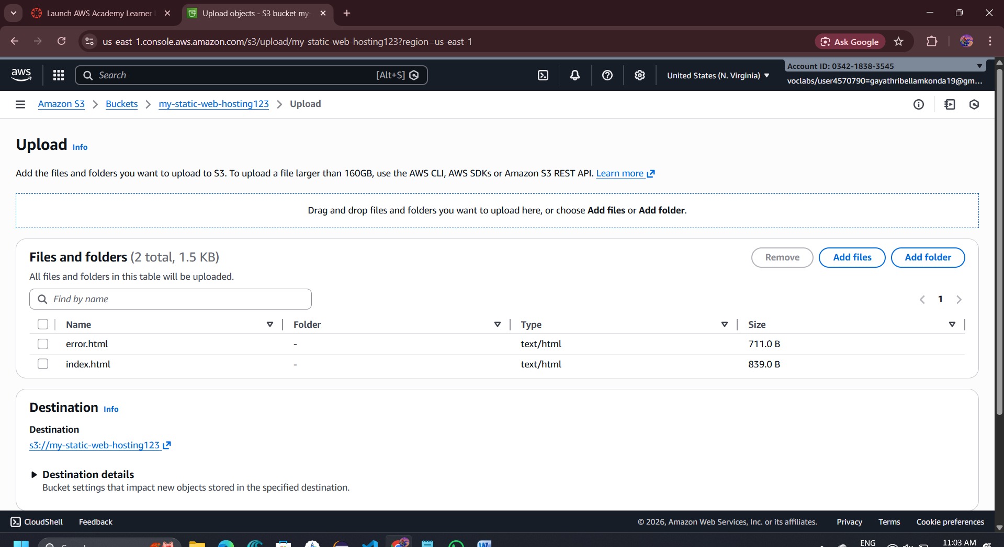

Click on bucket -> Go to Properties tab -> scroll to static website -> click on edit

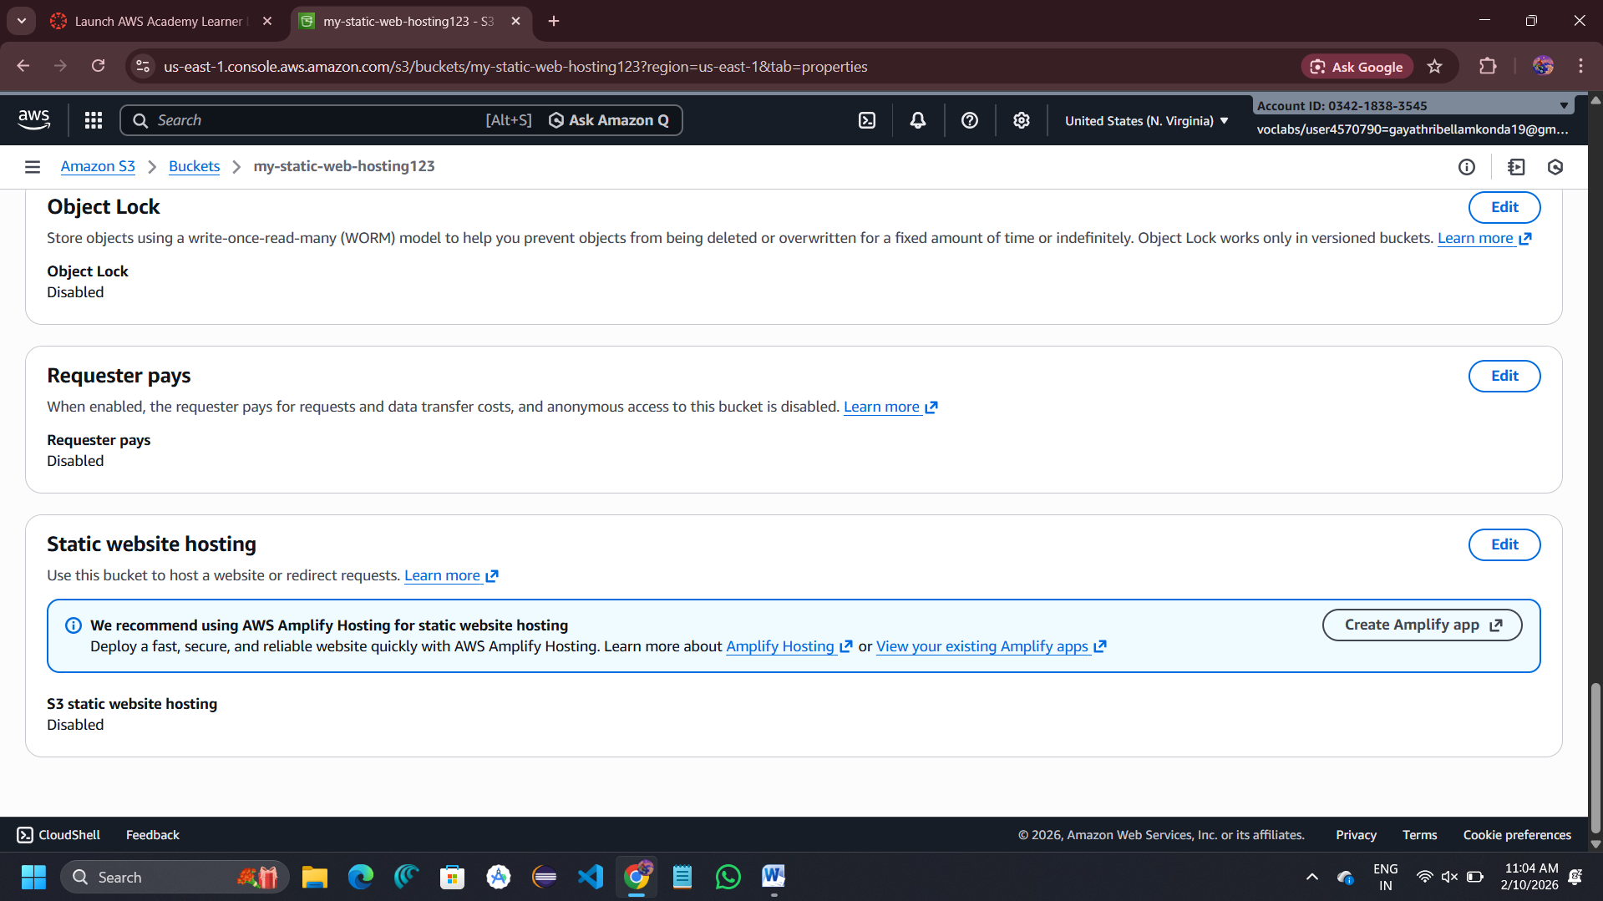

Enter : index document : index.html , error document :error.html

Click on save changes

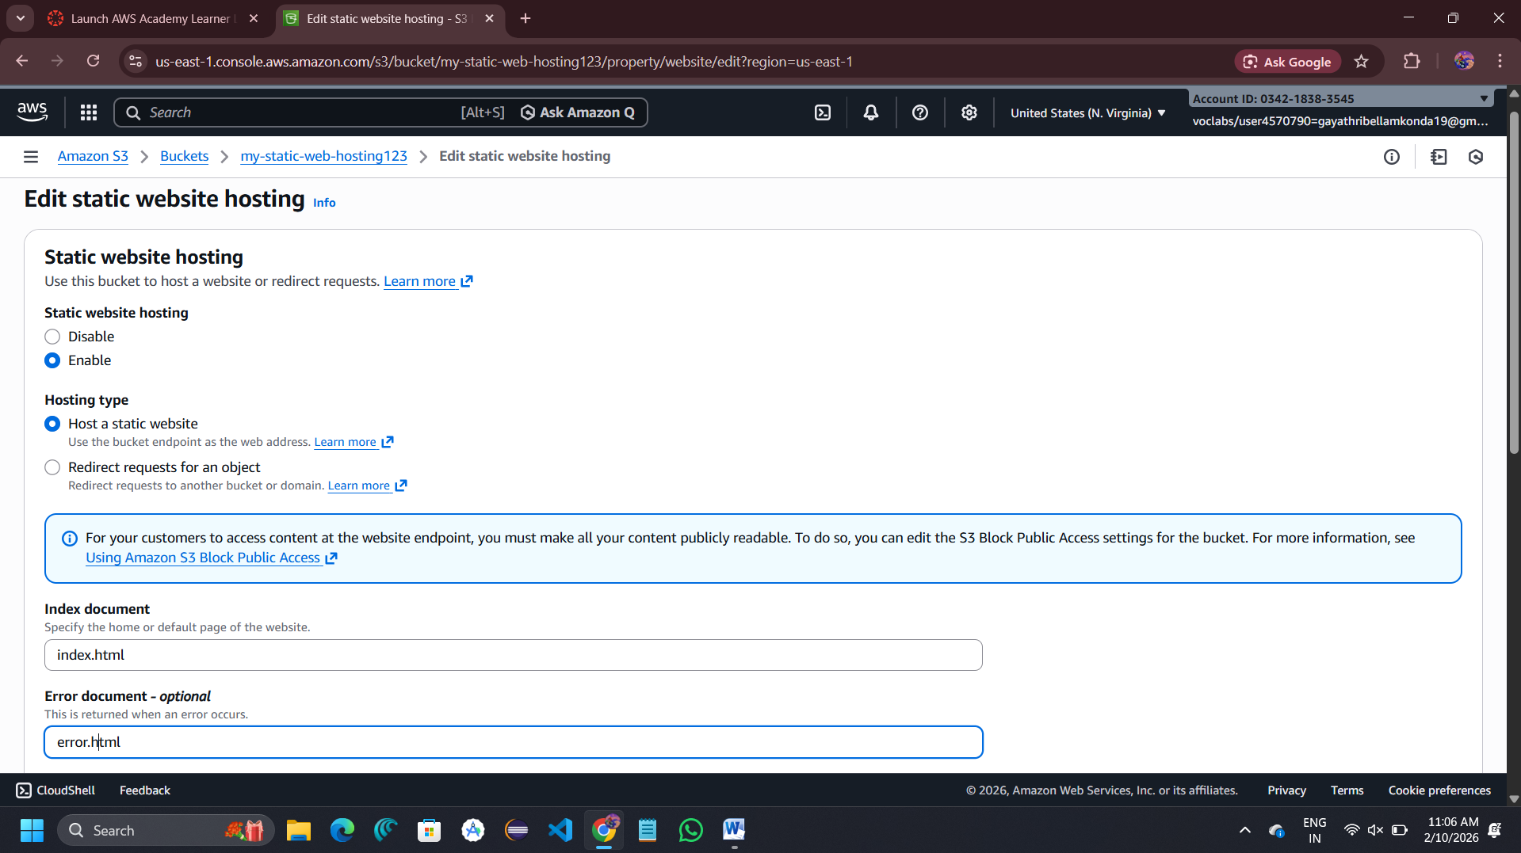

Click on bucket -> go to permissions -> click edit of object ownership

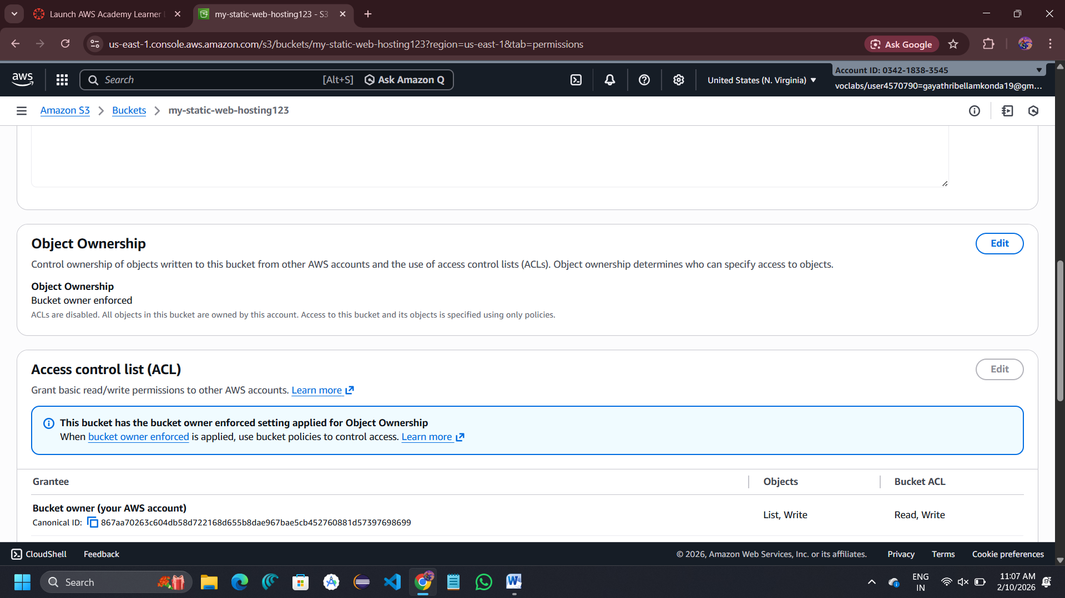

Select ACLs enebled -> click on I acknowledge -> save changes

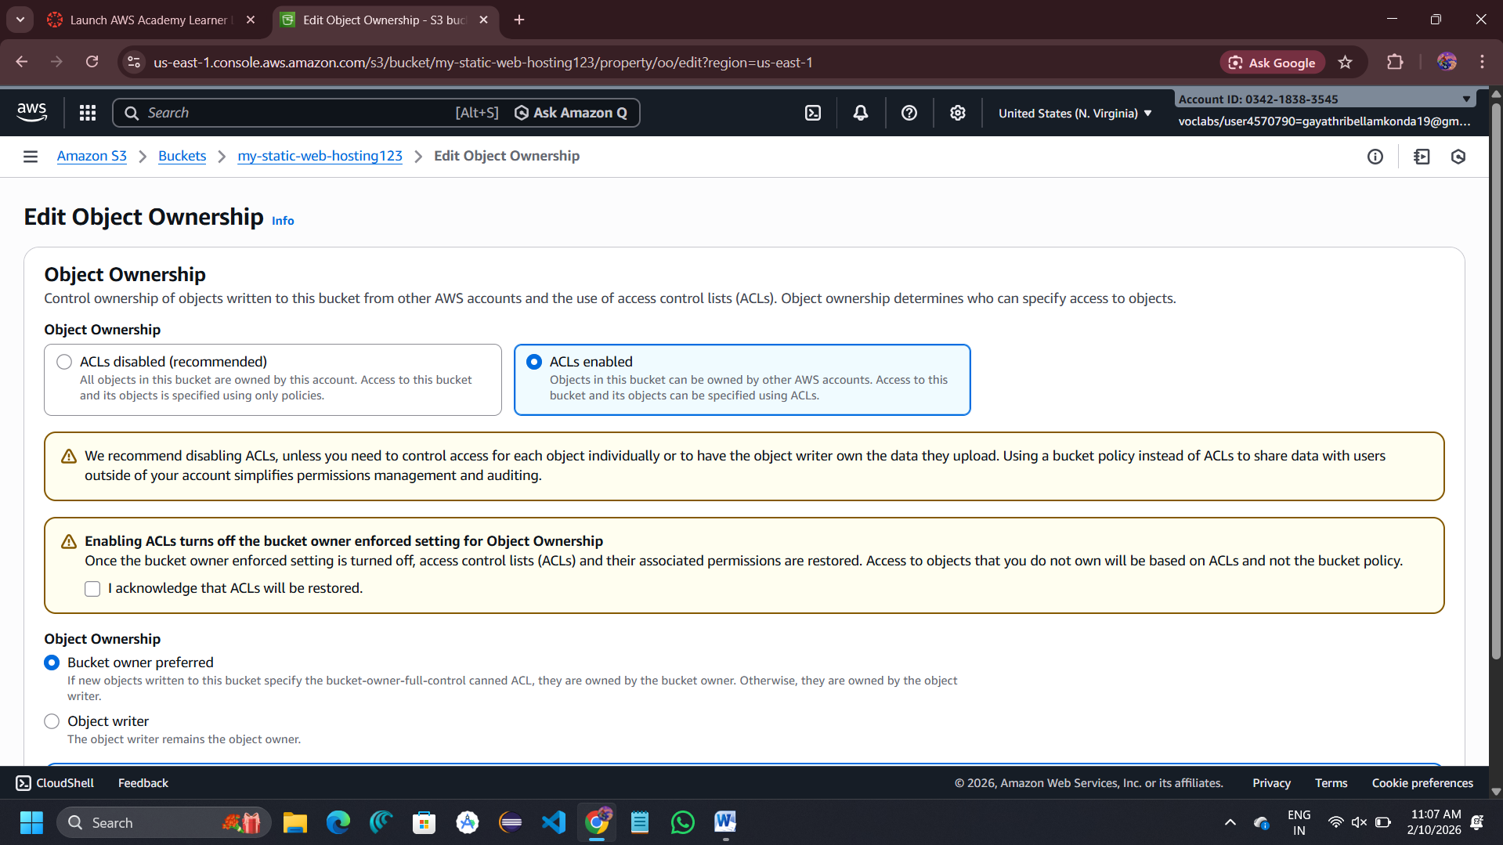

Go to bucket level permissions -> click on edit

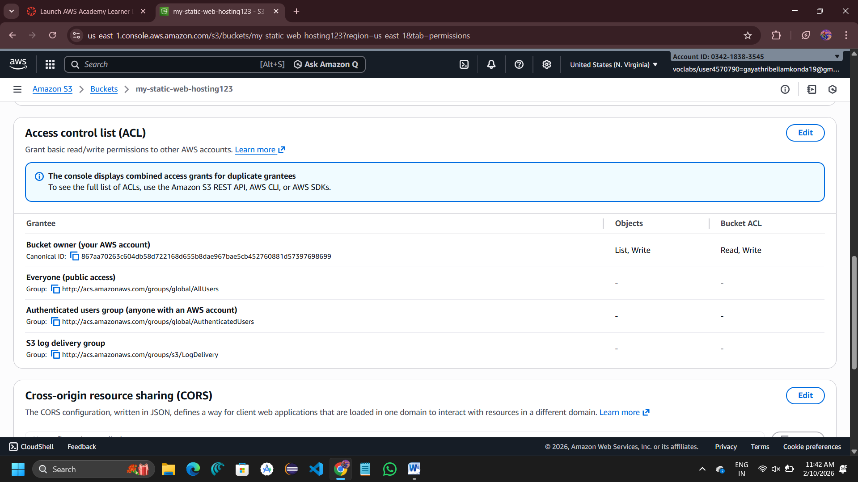

Select public access of objects and bucket ACL -> save the changes

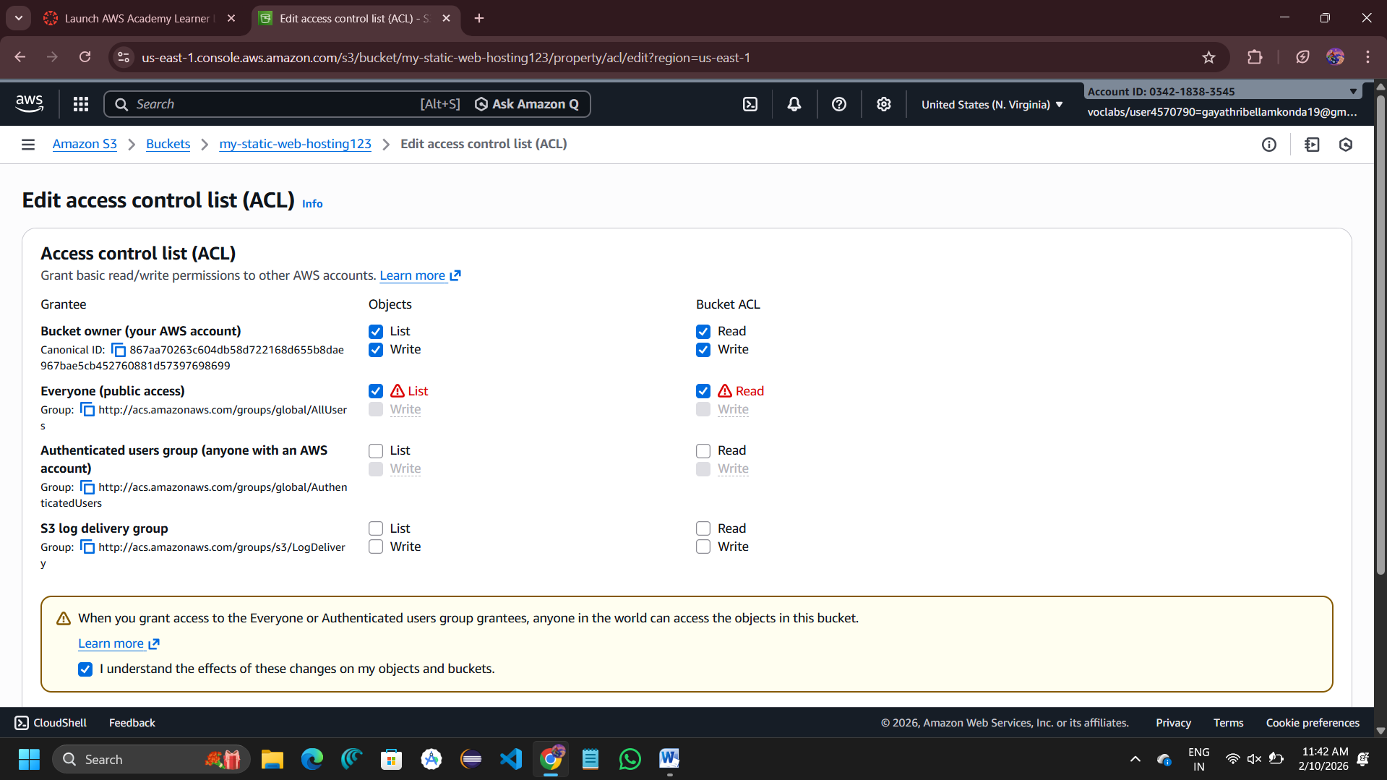

**Object-Level Public Access (ACL)**

Go to Objects tab -> click on index.html -> go to permissions

Scroll to access control list -> click on edit

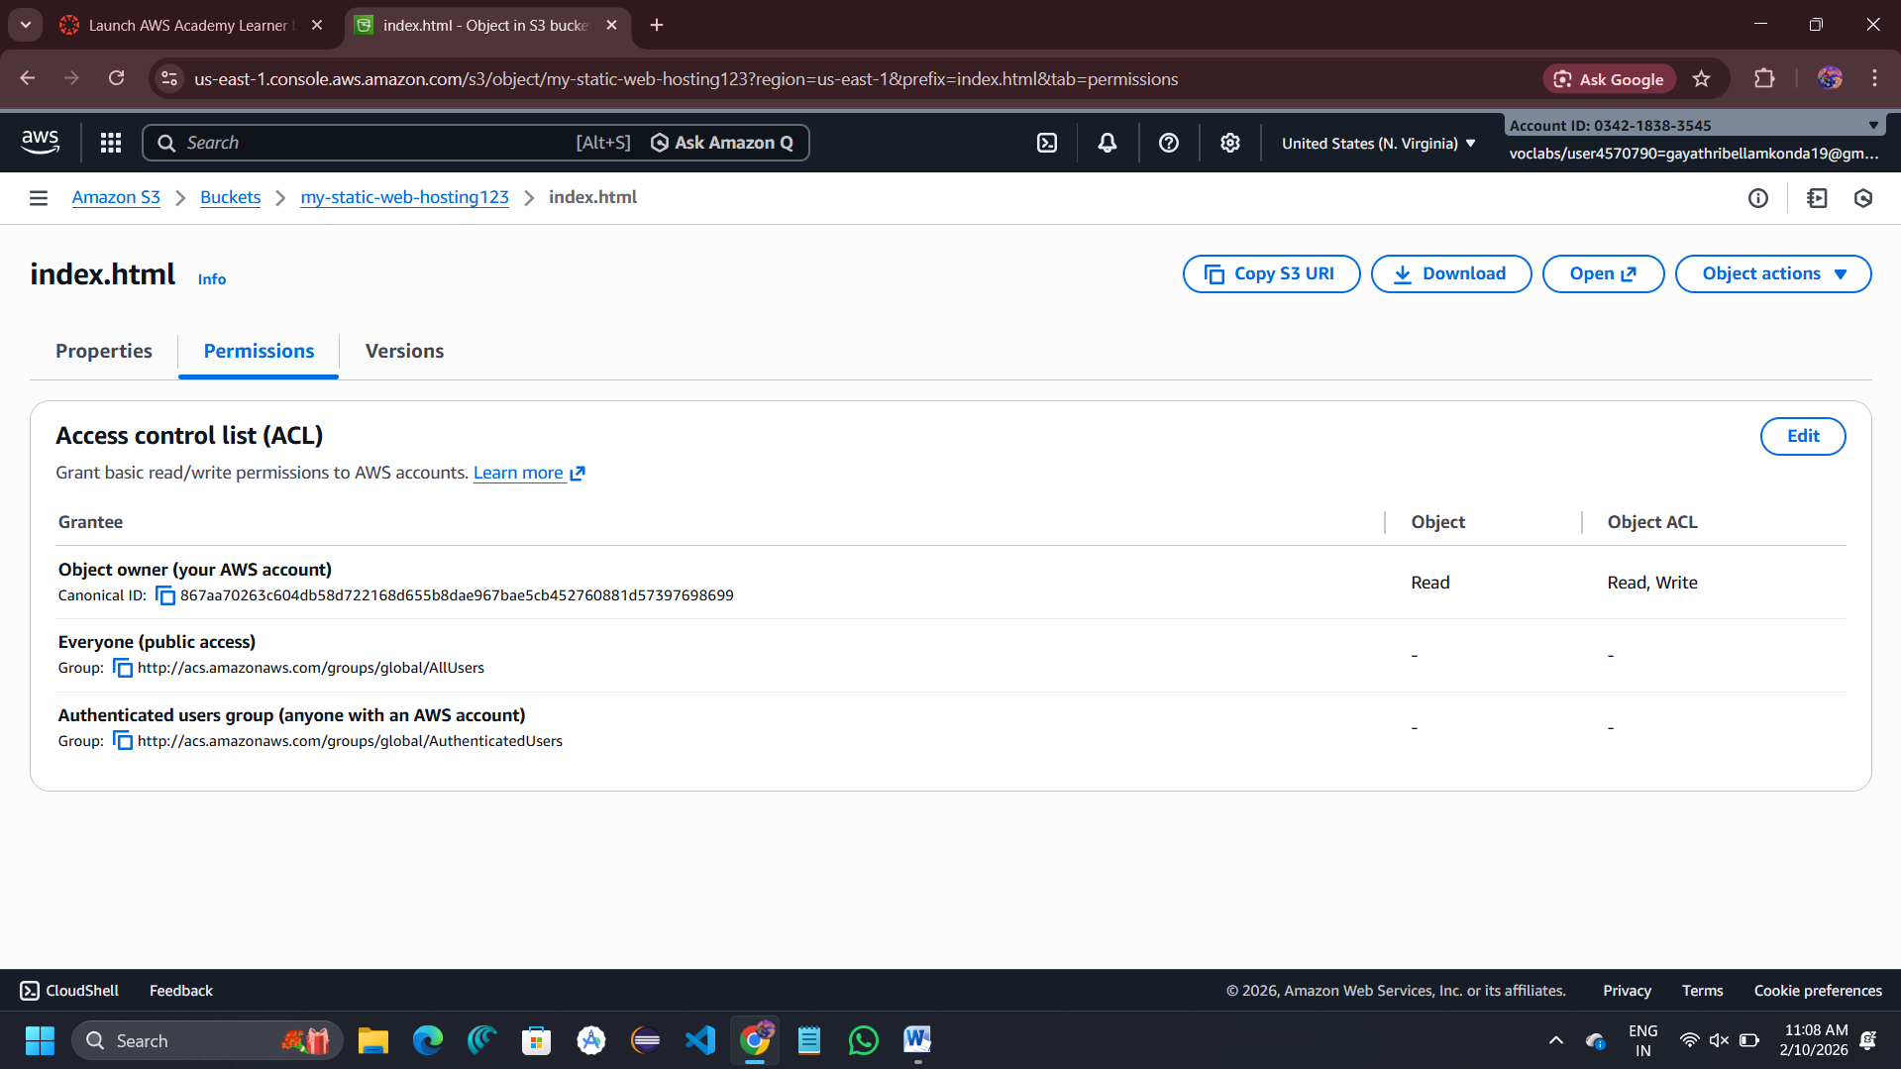

Under Public access: Everyone (public access) → Read -> Save changes

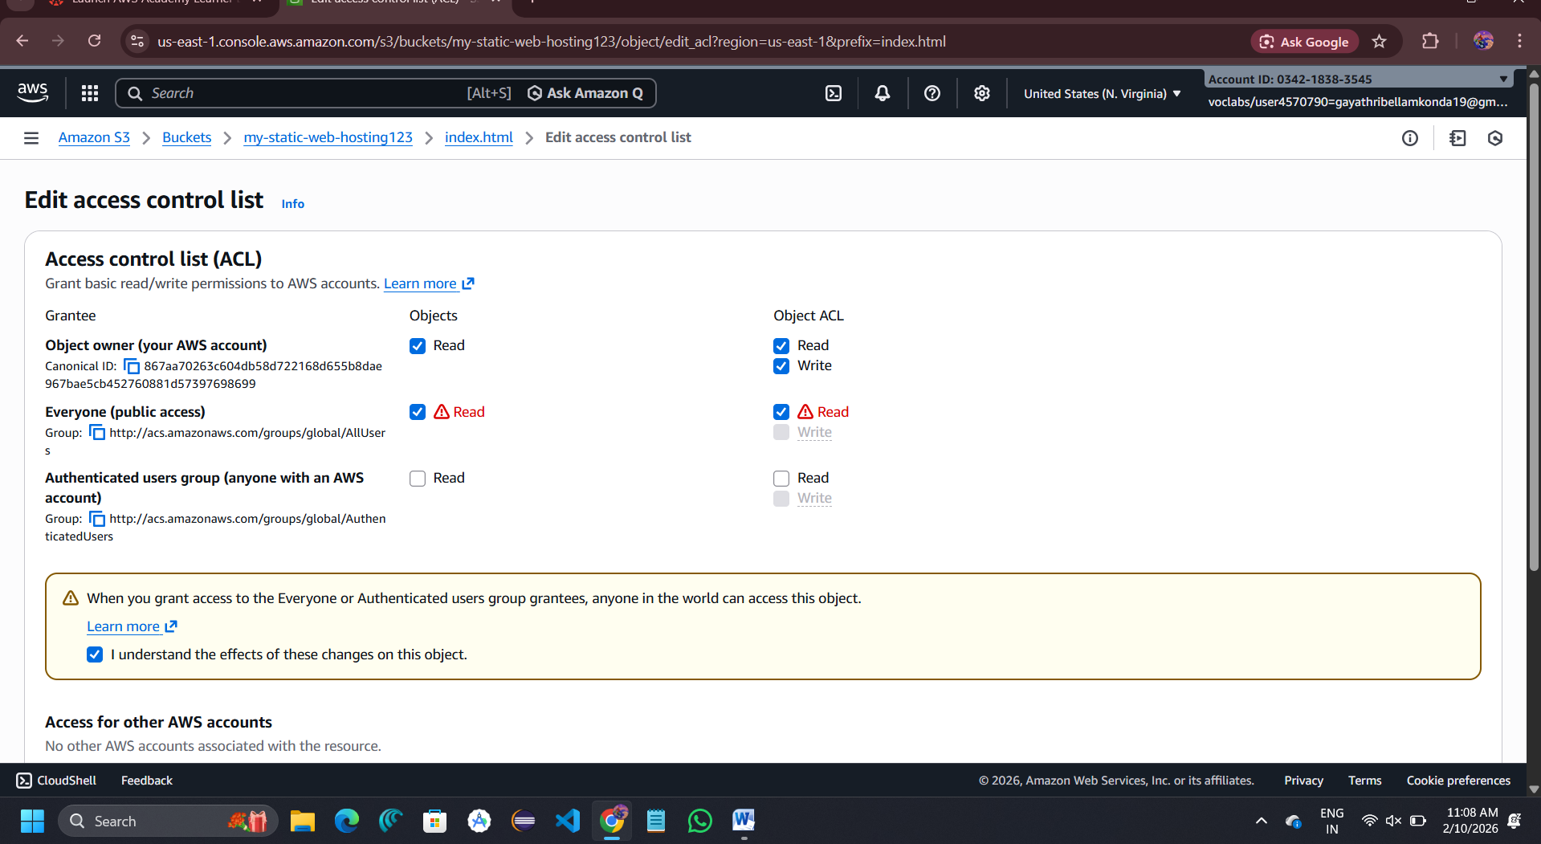

**Repeat the same steps for error.html**

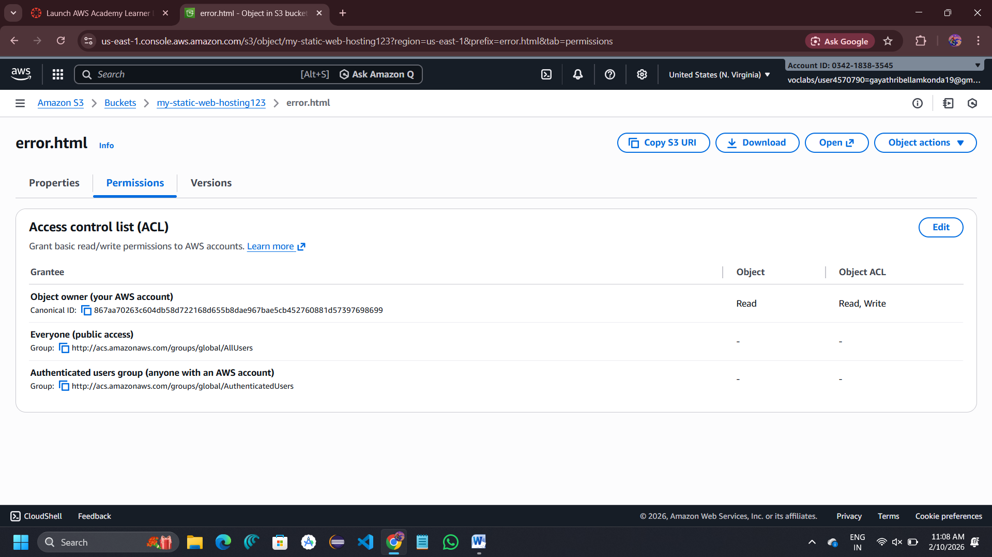

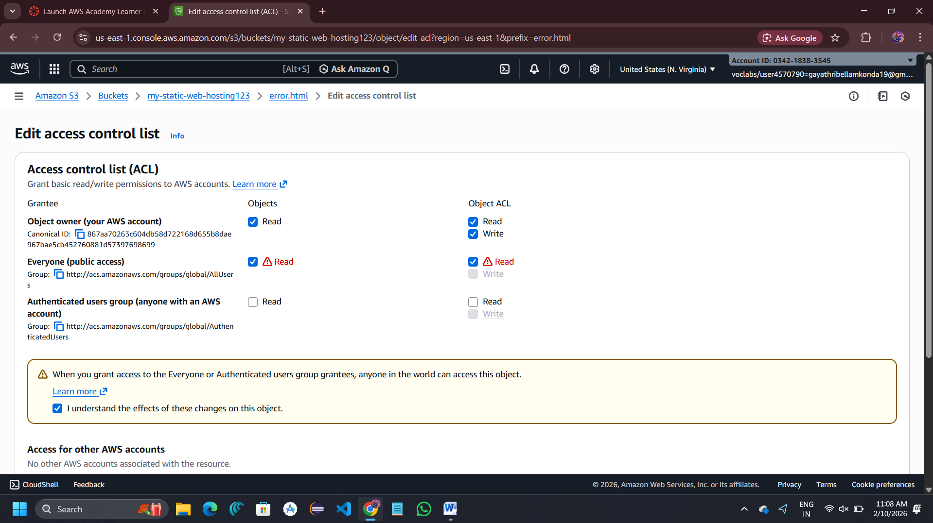

Go to bucket level Properties -> scroll to static website hosting -> copy the bucket website endpoint

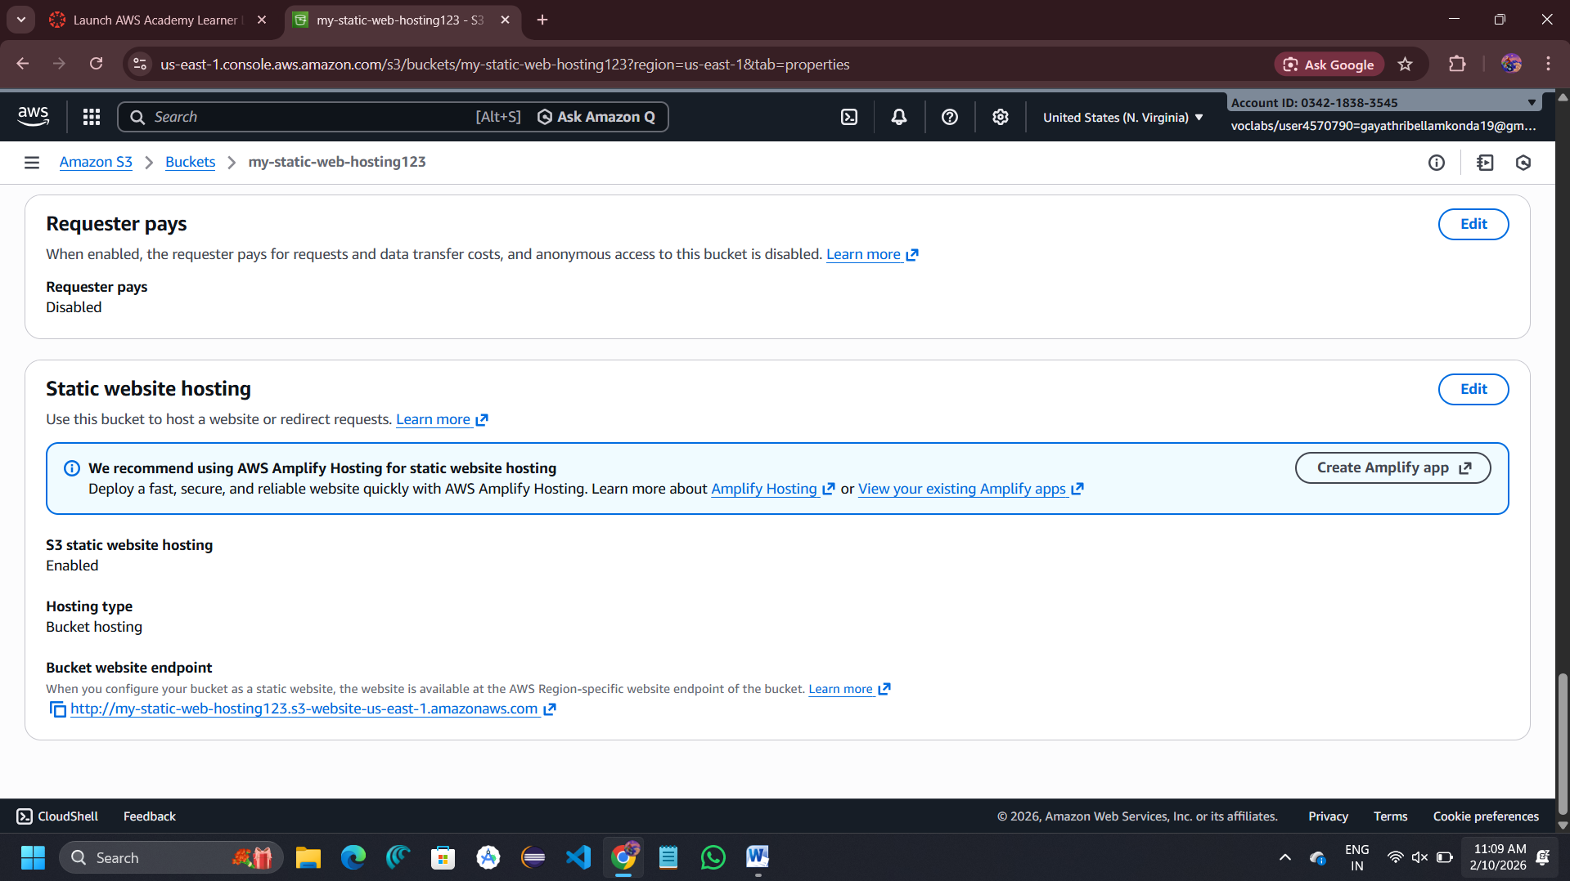

Copy the url into browser

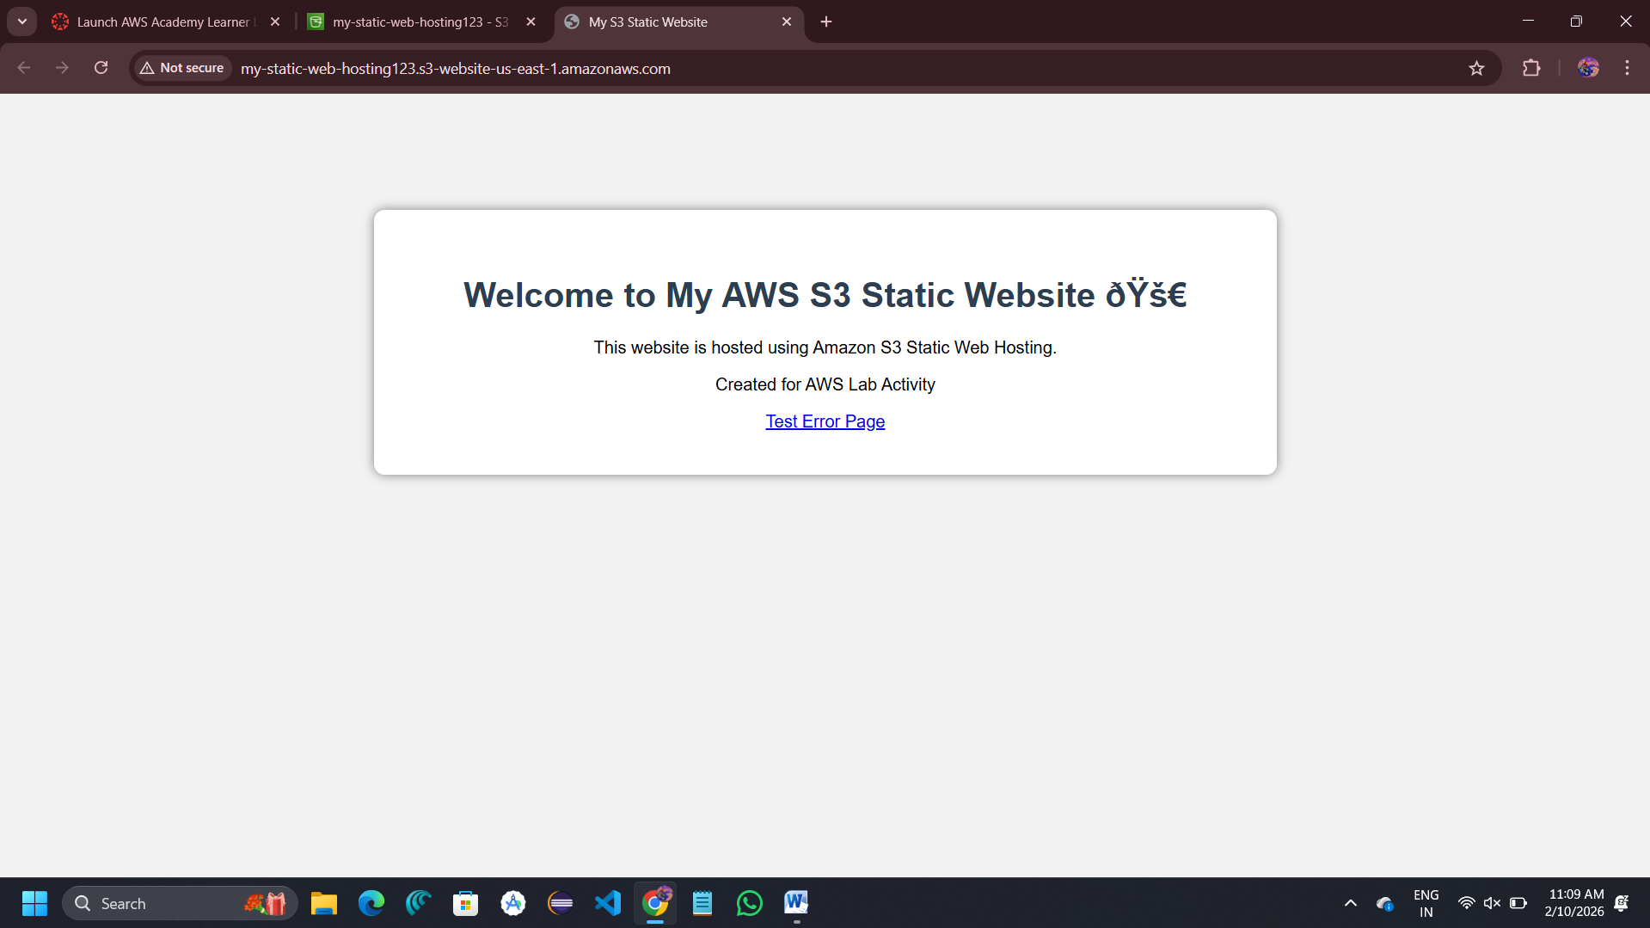

Test Error Page

* Open an invalid URL:
* error.html page is displayed

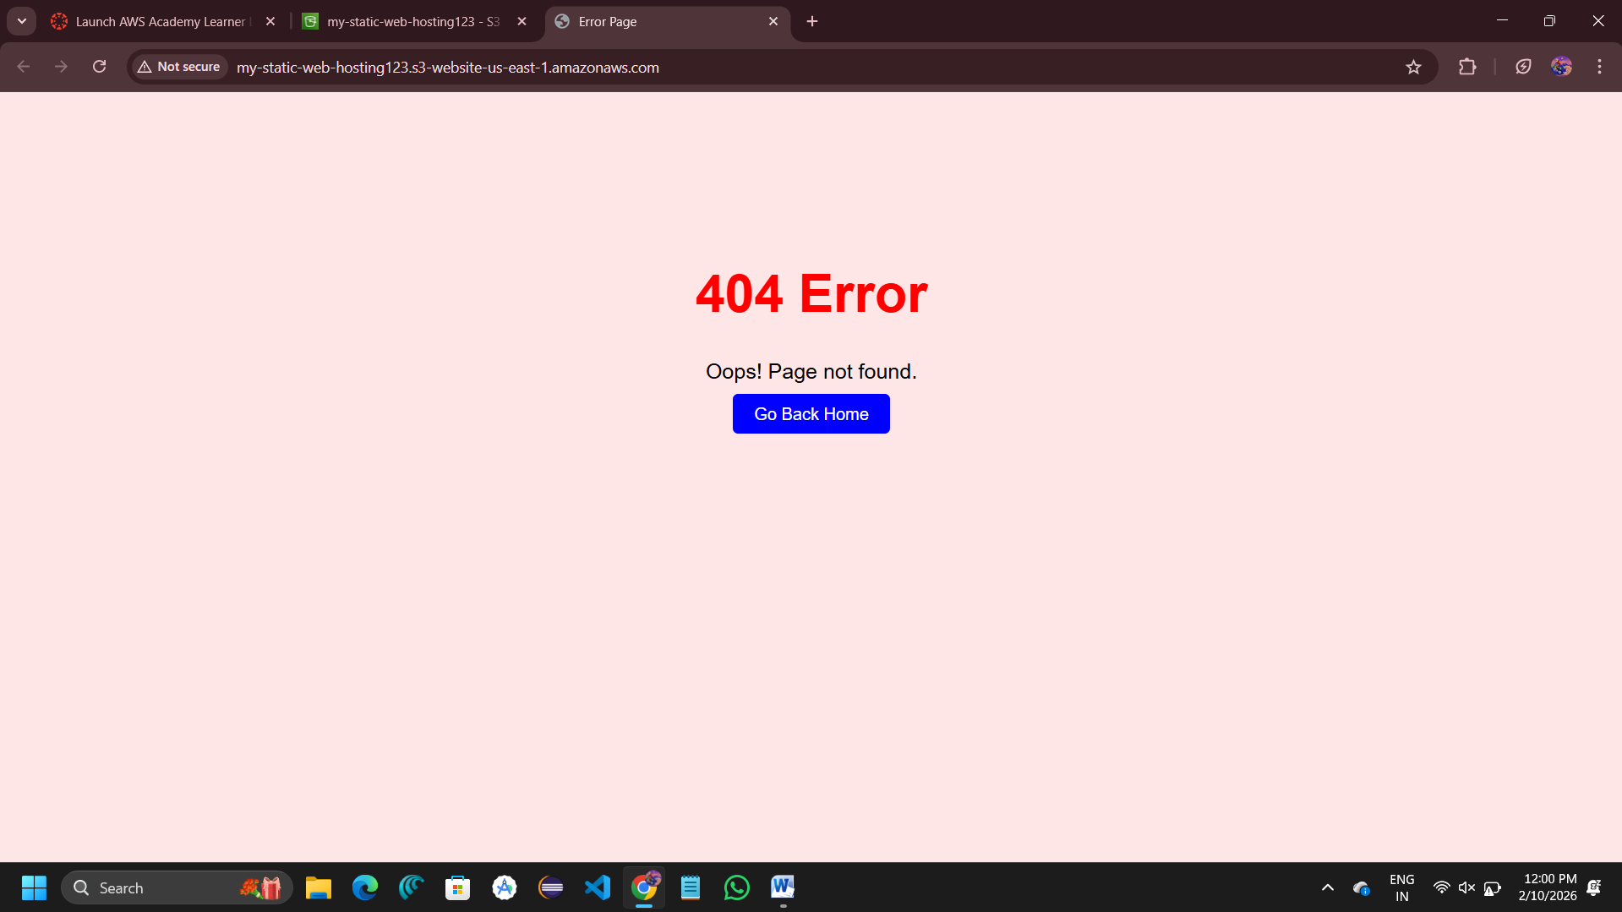

**Amazon S3 – Scenario-Based Questions**

**1. Developer uploaded object but cannot access from browser**

**Cause:** Object or bucket does not have **public read permission**.  
By default, S3 objects are private. Without:

* Public ACL OR
* Bucket policy allowing public read  
  browser access will be denied.

**2. Bucket policy allows public read but object not accessible**

**Reason:**  
Object-level permissions (ACL) may block access.

If object ACL is:

* Private OR
* Blocked by “Block Public Access”

Then object won't be accessible even if bucket policy allows it.

**3. No bucket policy but objects have public ACL**

**Yes**, users can access objects if public ACL is enabled.

**Final access decision depends on:**

* Bucket policy
* Object ACL
* Block public access settings

If none blocks access → object accessible.

**4. Prevent any public access even if ACL applied**

Enable: **Block Public Access (BPA)**

Specifically:  
Block all public access (ON)

This overrides:

* Bucket policies
* Object ACLs

Ensures no public exposure.

**5. Bucket naming error while creating**

S3 bucket naming rules:

* Must be globally unique
* Only lowercase letters
* No spaces
* No uppercase
* No special characters except hyphen (-)
* Length: 3–63 characters

If rule violated → naming error.

**6. Two accounts try same bucket name**

S3 bucket names are **globally unique across AWS**.

If one account creates:

project-backup-2026

No other account in world can create same name.

**7. Static website shows 403 Forbidden**

Most common cause:

Bucket or objects not public  
Block public access enabled

Fix:

* Add bucket policy for public read
* Disable block public access

**8. index.html not found error**

Actual issue:

Index document name incorrectly set  
OR  
index.html not uploaded to bucket root

Check:  
Static hosting → index document = index.html

**9. HTTP error when index missing**

**Error:** 404 Not Found

Reason:  
S3 static hosting searches for index.html.  
If not present → returns 404 error.

**10. Bucket policy public but site not working**

Verify **object-level permission**

Objects must:  
Have public read access

OR  
Not blocked by block public access

Even with bucket policy, object must allow access.

**11. Recover overwritten object (versioning enabled)**

Steps:

1. Open bucket → object
2. Go to **Versions**
3. Select older version
4. Click **Download** or **Restore**

Old file can be recovered easily.

**12. Delete object from versioned bucket**

Not permanently deleted immediately.

S3 adds:  
 **Delete marker**

Old versions still exist and can be restored.

Data removed permanently only if:

* All versions deleted manually

**13. CRR enabled but objects not replicating**

Possible missing configuration:

* Versioning not enabled on both buckets
* IAM replication role not created
* Destination bucket permissions missing

CRR needs versioning + IAM role.

**14. Only new objects replicating**

Because:

CRR works only for **new uploads after enabling replication**

Old objects require: Manual replication

or  
Batch replication

**15. Prerequisites for Cross-Region Replication**

Required:

1. Versioning enabled on both buckets
2. Destination bucket in different region
3. IAM role with replication permissions
4. Bucket policy allowing replication
5. Same account or cross-account permission

Used for:

* Disaster recovery
* Backup and Compliance